TASK MANAGEMENT SYSTEM

Database Management Systems

**MSCS 542L**

**Team Name: The Unstoppables**

**Marist College.**

**School of Computer Science and Mathematics.**

**Submitted to: Dr Reza Sadeghi Fall 2022**

**TABLE OF CONTENTS**

**Desired Group:………………………………………………………………………………………………..4**

PROJECT OBJECTIVE: 7

Admin user activities 7

Regular User activities 7

User Interface 8

REVIEW RELATED WORK: 8

MERITS: 9

GITHUB REPOSITORY ADDRESS 9

ER Diagram 11

Enhanced Entity-Relationship Model: 13

DATABASE DEVELOPMENT 15

Manipulating Data 39

ALTER DATA 39

OPTIMIZING DATABASE 42

Graphical user interface design 51

Connection in App Environment 52

Home Page Source Code 52

Screenshots: 55

Conclusion 56

Future Works 56

Referenece……………………………………………………………………………………………………57

# Table of Figures

Figure 1 Entity Relationship Model 11

Figure 2 EER Model 14

Figure 3 Users Table Inserted Data 24

Figure 4 User Alerts Table Inserted Data 26

Figure 5 user_user_alerts Table Inserted Data 26

Figure 6 task_task_tag Table Inserted Data 27

Figure 7 task_tags Table Inserted Data 28

Figure 8 task_statuses Table Inserted Data 29

Figure 9 tasks Table Inserted Data 30

Figure 10 role_user Table Inserted Data 31

Figure 11 roles Table Inserted Data 32

Figure 12 personal_access_tokens Table Inserted Data 33

Figure 13 password_resets Table Inserted Data 34

Figure 14 permissions Table Inserted Data 36

Figure 15 migrations Table Inserted Data 37

Figure 16 permission_role Table Inserted Data 38

Figure 17Alter Table Task 39

Figure 18 Drop Column 40

Figure 19 Alter Media Table 40

Figure 20 Select All Query 41

Figure 21Update Query 42

Figure 22 GUI Flow chart………………………………………………………………………………………

# Desired Group:

**Team Name: The Unstoppables Team Members:**

Yeshwanthy Puppala [yeshwanthy.puppala1@marist.edu](mailto:yeshwanthy.puppala1@marist.edu) (Team Head)

Natraj Adepu [natraj.adepu1@marist.edu](mailto:natraj.adepu1@marist.edu) (Team Member)

Chandra Shekar Reddy Ganna [chandrashekarreddy.ganna1@marist.edu](mailto:chandrashekarreddy.ganna1@marist.edu) (Team Member)

Venkatesh Pendli [venkateshwarlu.pendli1@marist.edu](mailto:venkateshwarlu.pendli1@marist.edu) (Team Member)

Akhil Sai Baru [akhilsai.baru1@marist.edu](mailto:akhilsai.baru1@marist.edu) (Team Member)

Thirumala Rao [Thirumalarao.yellisetti1@marist.edu](mailto:Thirumalarao.yellisetti1@marist.edu) (Team Member)

Pranay Reddy Kosireddy [Pranayreddy.kosireddy1@marist.edu](mailto:Pranayreddy.kosireddy1@marist.edu) (Team Member)

**Description of Team Members:**

**Yeshwanthy Puppala:**

My name is Yeshwanthy Puppala, I am from Hyderabad, India. I completed my Bachelors in the field of Computer Science and Engineering from Sreyas Institute of Engineering and Technology, Hyderabad in the year 2021. My interests are playing badminton, listening to music and podcasts. I worked as a Programmer Analyst Trainee for 9 months in Cognizant Company in the Automation domain. I would like to work with goal oriented, Optimistic people.

**Natraj Adepu :**

My name is Natraj Adepu i am from Hyderabad, India. i pursued my bachelors degree in the field of Computer Science & Engineering from lovely professional university which is in Punjab India

, later I did masters of business administration from lovely professional university and got placed as a operations intern in start-up company which is in Delhi India but my interest is to work in an IT field so quit the job and started preparation to get job in MNC, I got job in cognizant as a programmer analyst. where is got exposed to git hub, Agile methodology and i got chance to learn advanced python. I want to work with dedicated, enthusiastic and fast learners.

**Chandra Shekar Reddy Ganna:**

My name is Chandra Shekar Reddy Ganna, I am from Hyderabad, India. I completed my B.Tech in Comp. science from Lovely Professional University, in 2020.my interests are listening to music and reading books. I have 2+ years of experience as a storage QA, I got a chance to work with multiple enterprise data storage technologies like RAID, SAN, DAS and I worked with different file systems like NTFS, NFS, CIFS and I worked with different Operating system like Windows Linux, VMware ESXi. I tested Enterprise Storage System with different OS and file Systems I have experience working with Python. I would like to work with goal oriented, Optimistic people.

**Venkatesh Pendli:**

My name is Venkateshwarlu pendli, I am from Hyderabad, India. I completed my under graduation in the field of mechanical engineering from SRM University Chennai in the year 2018. I have 3+ years of experience as a Quality analyst in Amazon development center, where I need to analyze the Kindle data which is received from content publishers by using both counter punch and kdp tools.I have some knowledge on java and c programming language. I like to work with people who always tries to learn new things and Optimistic People.

**Baru Akhil Sai:**

My name is Akhil Sai Baru, I’m from Hyderabad, India. I completed my bachelors in the field of computer science from lovely professional university Jalandhar Punjab in the year 2020 my interests are playing chess, reading books and watching movies. I have one and half year experience as a cloud developer I used to work for an us based companies in different technologies. I would like to work with people who drive me forward and people who love to have fun.

**Thirumala Rao:**

My name is Thirumala Rao Yelisetti, I am from Hyderabad, India. I have completed my under graduation in the field of Electronics and Communication Engineering from Sreenidhi Institute of Science and Technology, Hyderabad in the year 2021.my interests are playing and watching cricket. I have 1 years of experience as a Project Engineer in Wipro. I have some knowledge on java and c programming language. My interests are watching and playing cricket, I like swimming. I like to work with people who always tries to learn new things and having good experience on various fields.

**Pranay Reddy Kosireddy:**

My name is Pranay Reddy Kosireddy, I am from Hyderabad, India. I completed my Bachelors in the field of Computer science from Osmania University, Hyderabad .my interests are listening to music and watching movies. I would like to work with focused, confident and creative mind people.

# PROJECT OBJECTIVE:

**Project Title**: Task Management System

**Summary**: A Task Management System (TMS) displays a calendar for the desired week, month, or year. also, TMS organizes personal tasks of different users on a specific day. the users can see their individual calendar data & update them. TMS will store the data of different user types in distinct SQL tables. Task management system at minimum supports the following:

### Admin user activities

* 1. Admin user can manage users by adding, editing or deleting users.
  2. Admin user can reset user passwords.
  3. Admin user can add normal user to TMS by creating a new name, email and password
  4. A normal user is not able to define or remove other users.
  5. Admin user can remove users from TMS by removing their username, Password and Data.
  6. Admin can create, edit or delete a Permission
  7. An Admin can add, edit or delete a Role (There are 2 roles by default: Admin, and user)
  8. The Admin can also add edit or delete tasks

### Regular User activities

* 1. Add a task to TMS. the task contains: Name/title, status, tags, attachment, due date, assignee and description.
  2. Remove a Task.
  3. Edit a task.

1. Search through tasks using Name/title, status, tags, attachment, due date, assignee and description of the task.
2. View calendar with scheduled tasks.
3. Create tags
4. Edit tasks statuses

## User Interface

It shows a welcome page and provides a menu of all functions to the user in all pages.

It illustrates the reports in a tabular form. for instance, it displays a well-organized calendar of every month with a list of tasks that are due on each day.

# REVIEW RELATED WORK:

There are many Task management Systems online. Wrike is one among them. Wrike provide features like Task Tracking, Task Removal, Task assigning but using Wrike we cannot update the task, Here the only way to update the task is to remove the task and then assign the new task. Wrike software is very complex to use, an ordinary person cannot use this software that easily moreover, Wrike software is using an outdated way to track the task status. Wrike software is not using noa tification system to notify the person regarding their Task, this may result in missing the task deadline.[2]

Monday.com is a Task Management Software which is customizable. Monday.com can obtain calendars and other task data at a glance.Monday.com automatically updates the timeline view when a task is assigned or updated or edited and, we can set priorities for tasks. But Monday.com is not providing a better notification system and the issue with Monday.com is Task Overlapping can occur. That means the admin can assign a task to the user who is already working on some tasks at the same time.[3]

Time Tap is Task scheduling software. Time Tap software is providing a user-friendly interface. It can detect time zones automatically. It can integrate with Google Calendar. It has automated email system to remind about task related notifications. We can also assign a task to employee by checking if he is not allotted with any task. Task pending notification feature is not available in Time Tap software[3].

# MERITS:

* Notification Functionality is used to notify about the task that is assigned to person.
* It helps to track all the assigned and updated tasks information instantly.
* It makes easier by displaying a calendar for the desired week, month, or year and organizes the personal tasks of different users on a specific day.
* It ensures customer satisfaction.
* Task Management System provides the feature of task status review.
* Users can also Update the Task which is already Assigned.

# GITHUB REPOSITORY ADDRESS

https://github.com/yeshuuu/MSCS-542L_TASK-MANAGEMENT- SYSTEM_THE- UNSTOPPABLES#mscs-542l_task-management-system_the- Unstoppables

## Entity Relationship Model

* + 11entities are chosen to establish a perfect relationship.
  + These 11 entities include the users, tasks, roles, permissions, user _ alerts, task _ tags, media, task_ status, personal _ access _ tokens, password _ rests, migrations.
  + Relationship between task and user is M:N, for media and task M: N, for task and task category 1:1, employee and task relationship are N:1. task and task update the relationship is 1:1. These are all related to their fellow entities bringing about a perfect collaboration. There is a one-to-one, one-to-many, and many-to-many type of relationship.
  + There are also a variety of attributes including names, specifications, data, passwords, user IDs, addresses, updated details, and many more.
  + There is a one-to- many relationship that is experienced to the highest level among one-to-one and many-to-many relationships.

|  |  |
| --- | --- |
| **Entity** | **Attributes** |
| Users | `id`, `name`, `email`, `email_verified_at`, `password`, `remember_token`, `created_at`, `updated_at`, `deleted_at` |
|  |  |
| User_alerts | `id`, `alert_text`, `alert_link`, `created_at`, `updated_at` |
| Tasks | `id`, `name`, `description`, `due_date`, `created_at`, `updated_at`, `deleted_at`, `status_id`, `assigned_to_id` |
| Task_statuses | `id`, `name`, `created_at`, `updated_at`, `deleted_at` |
| Task_tags | `id`, `name`, `created_at`, `updated_at`, `deleted_at` |
| Role | `id`, `title`, `created_at`, `updated_at`, `deleted_at` |
| Personal_access_tokens | `id`, `tokenable_type`, `tokenable_id`, `name`, `token`, `abilities`, `last_used_at`, `created_at`, `updated_at` |
| Permissions | `id`, `title`, `created_at`, `updated_at`, `deleted_at` |
| Password_resets | `email`, `token`, `created_at` |
| Migrations | `id`, `migration`, `batch` |
| Media | `id`, `model_type`, `model_id`, `uuid`, `collection_name`, `name`, `file_name`, `mime_type`, `disk`, `conversions_disk`, `size`, `manipulations`, `custom_properties`, `generated_conversions`, `responsive_images`, `order_column`, `created_at`, `updated_at` |
|  |  |
|  |  |
|  |  |
|  |  |

Table Entities and Attributes Table

## 

## ER Diagram

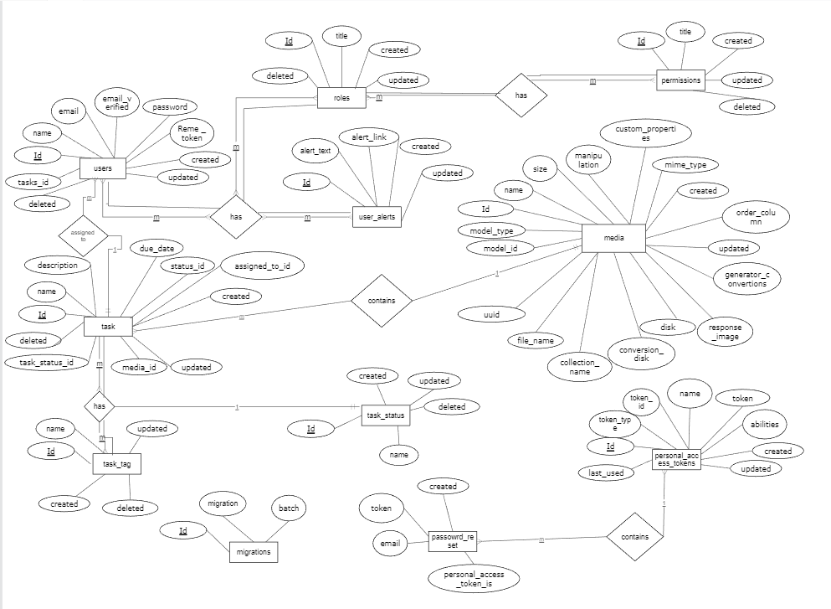

Figure Entity Relationship Model

The Entity Relationship Diagram Cardinality for Task Management System is about the number of interactions between entities.

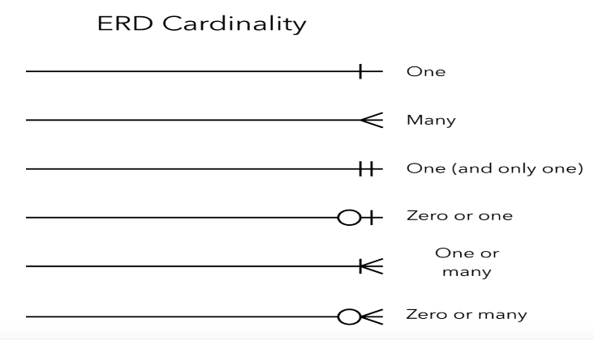

* One- to one: - One entity shares one event with another entity in a one-to-one (1:1) relationship.
* One-to-many: -In one-to-many (1: N) relationship, one entity only experiences an event once, but the other entity may experience the same event multiple times.
* Many-to-many: - When the same event or interaction occurs more than once between both entities, it is known as a many-to-many relationship.

* Total participation: - Every entity is a part of the relationship. Double lines signify the total number of participants.
* Partial participation: - It states that each entity in the entity set has the option of participating in a certain relationship instance in that relationship set.

## Enhanced Entity-Relationship Model:

* We are treating all these relationships within this model. If suppose, the task date is the primary key, the other entities and attributes are linked to it. All the attributes also have a relationship that they share between each of them.
* For the User table **id** is primary key, for task **id** is primary key. For task tags **tasks_ tag_ id** is primary key. Users_ alerts _ id and roles _idis foreign key. For task table **id** is primary key and **media_ id, task_status_ id** is foreign key. For Password_ resets **Reset_ id** is primary key. **Created timesetamp, token_ id** is foreign key. Media table has Media_ **id** is primary key. roles table has **roles_id** primary key.
* This is not just about the entity base relationship, but it is also about the interconnectedness. The data type that comes along with these includes the basic context of the specification, tasks, roles, permission_role and many more.
* These include integers, Boolean values, and many more.

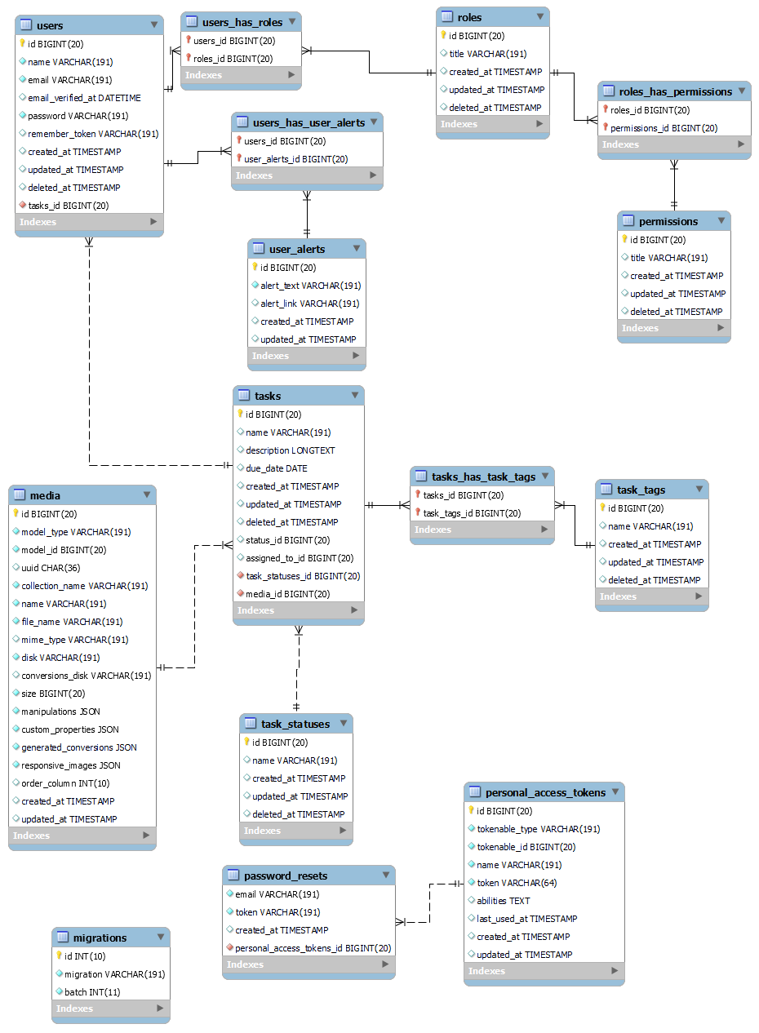

Figure EER Model

# DATABASE DEVELOPMENT

**USERS TABLE: -**

* The code created using DDL command with table name “Users”.
* The users table includes 9 attributes where id is a primary key with the datatype of BIGINT (20) and stated as NOT NULL so that this field cannot be null.

CREATE TABLE IF NOT EXISTS `users` (

`id` bigint(20) UNSIGNED NOT NULL AUTO_INCREMENT,

`name` varchar(191),

`email` varchar(191),

`email_verified_at` datetime,

`password` varchar(191),

`remember_token` varchar(191),

`created_at` timestamp,

`updated_at` timestamp,

`deleted_at` timestamp,

PRIMARY KEY (`id`)

)

ENGINE=MyISAM AUTO_INCREMENT=11 DEFAULT CHARSET=utf8mb4 COLLATE=utf8mb4_unicode_ci;

**USER_USER_ALERT TABLE**

* The code created using DDL command with table name “**USER_USER_ALERT TABLE**”.
* The table includes 3 attributes where user_alert_id is a primary key with the datatype of BIGINT and stated as NOT NULL so that this field cannot be null. The attributes user_alert_id, user_id are declared using BIGINT.

CREATE TABLE IF NOT EXISTS `tmsdb`.`user_user_alert` (

`user_alert_id` bigint(20) UNSIGNED NOT NULL AUTO_INCREMENT,

`user_id` bigint(20) UNSIGNED NOT NULL,

`read` tinyint(1)

)

ENGINE=MyISAM AUTO_INCREMENT=11 DEFAULT CHARSET=utf8mb4 COLLATE=utf8mb4_unicode_ci;

**USER_ALERTS TABLE: -**

* The code created using DDL command with table name “**USER_ALERTS**”.
* The admin table includes seven attributes where user_alerts_id with the datatype of BIGINT and stated as NOT NULL so that this field cannot be null.

CREATE TABLE IF NOT EXISTS `tmsdb`.`user_alerts` (

`id` bigint(20)UNSIGNEDNOTNULLAUTO_INCREMENT,

`alert_text` varchar(191),

`alert_link` varchar(191),

`created_at` timestamp,

`updated_at` timestamp,

PRIMARY KEY (`id`)

)

ENGINE=MyISAM AUTO_INCREMENT=11 DEFAULT CHARSET=utf8mb4 COLLATE=utf8mb4_unicode_ci;

**TASKS TABLE: -**

* The code created using DDL command with table name “tasks”.
* The table includes 9 attributes where id is a primary key with the datatype of INT and stated as NOT NULL so that this field cannot be null.
* CREATE TABLE IF NOT EXISTS `tmsdb`.`tasks` (

`id` bigint(20) UNSIGNED NOT NULL AUTO_INCREMENT,

`name` varchar(191),

`description` longtext,

`due_date` date ,

`created_at` timestamp,

`updated_at` timestamp ,

`deleted_at` timestamp ,

`status_id` bigint(20) UNSIGNED,

`assigned_to_id` bigint(20) UNSIGNED,

PRIMARY KEY (`id`)

)

ENGINE=MyISAM AUTO_INCREMENT=11 DEFAULT CHARSET=utf8mb4 COLLATE=utf8mb4_unicode_ci;

**TASK_TASK_TAG TABLE: -**

* The code created using DDL command with table name “TASK_TASK_TAG”.

CREATE TABLE IF NOT EXISTS `tmsdb`.`task_task_tag` (

`task_id` bigint(20) UNSIGNED,

`task_tag_id` bigint(20) UNSIGNED

)

ENGINE=MyISAM AUTO_INCREMENT=11 DEFAULT CHARSET=utf8mb4 COLLATE=utf8mb4_unicode_ci;

**TASK_TAGS TABLE: -**

* The code created using DDL command with table name “task_tags”.

CREATE TABLE IF NOT EXISTS `tmsdb`.`task_tags` (

`id` bigint(20) UNSIGNED AUTO_INCREMENT,

`name` varchar(191),

`created_at` timestamp,

`updated_at` timestamp,

`deleted_at` timestamp,

PRIMARY KEY (`id`)

)

ENGINE=MyISAM AUTO_INCREMENT=11 DEFAULT CHARSET=utf8mb4 COLLATE=utf8mb4_unicode_ci;

**TASK_STATUSES TABLE: -**

* The code created using DDL command with table name “task_statuses”.

CREATE TABLE IF NOT EXISTS `tmsdb`.`task_statuses` (

`id` bigint(20) UNSIGNED AUTO_INCREMENT,

`name` varchar(191),

`created_at` timestamp,

`updated_at` timestamp,

`deleted_at` timestamp,

PRIMARY KEY (`id`)

)

ENGINE=MyISAM AUTO_INCREMENT=11 DEFAULT CHARSET=utf8mb4 COLLATE=utf8mb4_unicode_ci;

**ROLES TABLE:**

CREATE TABLE IF NOT EXISTS `tmsdb`.`roles` (

`id` bigint(20) UNSIGNED AUTO_INCREMENT,

`title` varchar(191),

`created_at` timestamp,

`updated_at` timestamp,

`deleted_at` timestamp,

PRIMARY KEY (`id`)

)

ENGINE=MyISAM AUTO_INCREMENT=11 DEFAULT CHARSET=utf8mb4 COLLATE=utf8mb4_unicode_ci;

**ROLE_USER TABLE: -**

CREATE TABLE IF NOT EXISTS `tmsdb`.`role_user` (

`user_id` bigint(20) UNSIGNED,

`role_id` bigint(20) UNSIGNED

)

ENGINE=MyISAM AUTO_INCREMENT=11 DEFAULT CHARSET=utf8mb4 COLLATE=utf8mb4_unicode_ci;

**PERSONAL_ACCESS_TOKENS TABLE: -**

CREATE TABLE IF NOT EXISTS `tmsdb`.`personal_access_tokens` (

`id` bigint(20) UNSIGNED AUTO_INCREMENT,

`tokenable_type` varchar(191),

`tokenable_id` bigint(20) UNSIGNED,

`name` varchar(191),

`token` varchar(64),

`abilities` text,

`last_used_at` timestamp,

`created_at` timestamp,

`updated_at` timestamp,

`deleted_at` timestamp,

PRIMARY KEY (`id`)

)

ENGINE=MyISAM AUTO_INCREMENT=11 DEFAULT CHARSET=utf8mb4 COLLATE=utf8mb4_unicode_ci;

**PERMISSIONS TABLE: -**

CREATE TABLE IF NOT EXISTS `tmsdb`.`permissions` (

`id` bigint(20) UNSIGNED AUTO_INCREMENT,

`title` varchar(191),

`created_at` timestamp,

`updated_at` timestamp,

`deleted_at` timestamp,

PRIMARY KEY (`id`)

)

ENGINE=MyISAM AUTO_INCREMENT=11 DEFAULT CHARSET=utf8mb4 COLLATE=utf8mb4_unicode_ci; `

**ROLES TABLE:-**

CREATE TABLE IF NOT EXISTS `tmsdb`.`roles` (

`role_id` bigint(20) UNSIGNED,

`permission_id` bigint(20) UNSIGNED

)

ENGINE=MyISAM AUTO_INCREMENT=11 DEFAULT CHARSET=utf8mb4 COLLATE=utf8mb4_unicode_ci;

**PASSWORD RESETS**

CREATE TABLE IF NOT EXISTS `tmsdb`.`password_resets` (

`email` varchar(191),

`token` varchar(191),

`created_at` timestamp

)

ENGINE=MyISAM AUTO_INCREMENT=11 DEFAULT CHARSET=utf8mb4 COLLATE=utf8mb4_unicode_ci;

**MIGRATIONS TABLE:-**

CREATE TABLE IF NOT EXISTS `tmsdb`.`migrations` (

`id` bigint(20) UNSIGNED AUTO_INCREMENT,

`migration` varchar(191),

`batch` int(11),

PRIMARY KEY (`id`)

)

ENGINE=MyISAM AUTO_INCREMENT=11 DEFAULT CHARSET=utf8mb4 COLLATE=utf8mb4_unicode_ci;

**MEDIA TABLE:-**

CREATE TABLE IF NOT EXISTS `tmsdb`.`media` (

`id` bigint(20) UNSIGNED AUTO_INCREMENT,

`model_type` varchar(191),

`model_id` bigint(20) UNSIGNED,

`uuid` char(36),

`collection_name` varchar(191),

`name` varchar(191),

`file_name` varchar(191),

`mime_type` varchar(191),

`disk` varchar(191),

`conversions_disk` varchar(191),

`size` bigint(20) UNSIGNED,

`manipulations` json,

`custom_properties` json,

`generated_conversions` json,

`responsive_images` json,

`order_column` int(10) UNSIGNED,

`title` varchar(191),

`created_at` timestamp,

`updated_at` timestamp,

`deleted_at` timestamp,

PRIMARY KEY (`id`)

)

**DATA INSERTION:**

We use INSERT command which comes under Data Manipulation Language to insert one or more rows into a table by giving values.

**SET FOREIGN_KEY_CHECKS=0;**

Error Code: 1452. Cannot add or update a child row: a foreign key constraint fails (`task_tags`.`task`, CONSTRAINT `fk1` FOREIGN KEY (`mid`) REFERENCES `Users` (`mid`)).

**INSERT**

**USERS TABLE**

INSERT INTO users(id, name, email, email_verified_at, password, remember_token, created_at, updated_at, deleted_at) VALUES(1, 'Dominique1973', 'LaurenMoreland@example.com', '2017-10-30 06:20:16', 'eAH4EPhQ7O4cKKgXZsSmig==','48591FMH3W454YEMT00NY6Z4VC2RU19X38B7K028335S662T55PFBC0TUD4R9EGSZQ7B722612FT0182R1JAL8ZFZZ388KCO14O4Q1C700M11W5742I23JMB7H2I64CIKS3V652', '1985-07-14 13:08:49', '1994-12-23 18:13:05', '1971-01-01 00:00:05'),(2, 'Glynda1950', 'TempleWiseman595@example.com','2004122408:28:22','tq/IrAdqng2ESTRLIZWM5A==','WTYK9Q0VD0OB1AMCCRKU7YB3AP25QW45D783ZT1JC7MPO0DCR5J09JZVZMP8KRV883G5ZX2HR6Z67P33043LC1J0', '1990-09-21 15:32:50', '1983-07-24 12:07:24', '1976-03-10 02:24:06'),(3, 'Redman2024', 'Dane.Simms@example.com','2012071615:56:19','iUtO5pM/bWoxxG8Six3wLA==','5LTHMPN8C78R160RA55I8717DMS789N6F34UX280849P5CXWX4X83HK68RE915M3AK4Z60D8O091Z4AP2ZSRX9B53374', '2008-01-13 18:34:53', '2000-03-01 20:37:06', '2019-11-29 17:25:01'),(4, 'Antionette1953', 'Eun.O.Barham793@example.com',NULL,'xl6GkQrHKHaxJCnBQxBZxg==','SC4U1UR56ULA7M284858667MNGY9MN0J47T6D830Q74G9428HN7LWV0GD9RIJOXGY0S3K4WFQ81W7N624020UV5UV272M44T3K58OJU84MCD3K044J3RAG8P31388684L8U20UYI71HA8L9', '1997-09-25 22:45:43', '2011-12-20 10:55:58', '2006-11-15 19:52:13'),(5, 'Shenita2022', 'ParisAhmed@example.com', '2017-10-30 06:20:17', 'qXkl6CUL9CW2KCSYETU6Fw==','F89S9T36022EI078LI632MO6LD951X4T7BPBTDCMHHPDBB739923NN8MOS3EWE428DPGAQMJ38CE1164V6U75', '1975-08-30 22:38:58', NULL, '1986-08-12 02:26:58'),(6, 'Cleta313', 'Mcneal@example.com', '2010-04-08 22:52:23', 'xGl7u9arDy0F5HyVrOqVLg==', '7V8KMX6LD9SJUT07I67PWI9328', '2002-11-05 16:10:53', '1980-03-28 23:08:51', '1971-01-01 00:00:06'),(7, 'Hertha2010', 'vcui5257@nowhere.com', '1973-06-08 05:22:37','66+vm/atj5iLhoExn2Hu+g==', 'VS11W214R21YBZSR9R6G783E38A09B0L23191AKPL9X0', '1980-11-07 01:02:59', '1994-12-23 18:13:06', '2014-09-21 15:01:04'),(8, 'Romeo11', 'Steffen@example.com', '1982-07-10 17:37:04', 'JP0FSpIhH4x3lgoA7GQyrQ==', '02CVF1ZRJKZ9UM25QTD7', '1975-08-30 22:38:59', '2015-12-10 22:35:42', '1993-11-21 16:05:29'),(9, 'Selene2001', 'DaronFrancis747@example.com', '2012-07-16 15:56:20', 'GfHPyOUsYi8CN0ZyowxTHg==', NULL, '2008-01-13 18:34:54', '1988-09-30 14:31:25', '1981-06-04 00:02:58'),(10, 'Carey1', 'Bible@example.com', '2017-10-30 06:20:18', 'AFJN9wZWgkc04AR+LTlAQA==', '902491NRT0S31XQ33A9R36PBWFUO3PRBL39T5XVZ7MQ522X4P123', NULL, '2000-03-01 20:37:07', NULL);

**Inserted data**

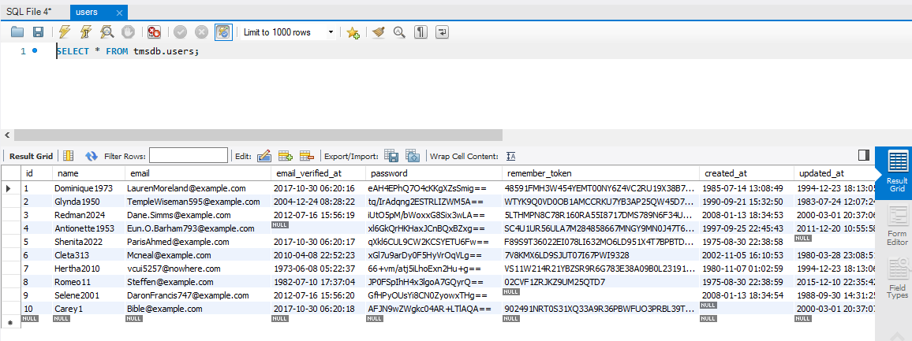

Figure Users Table Inserted Data

**USER_ALERTS**

INSERT INTO user_alerts(id, alert_text, alert_link, created_at, updated_at) VALUES

(1,'U8ME9LC88U4K0NN411S08R3S2556J5G30T06WXZ6PA25T05ODHZLDODEE1OD6JRXE0F6NHKCAFP8996MV35CI9A8IXG0549279690Y896121032GWV6874QCGSU51R1F79062MY2WC31H307F632X9232ACHP668161Q01H35VQ06FTE718SQQC5FF','J60A31643MI66H0TV2Q11RN35WJS941AX9M88MM49KFXE7G505DPOR0N7DFYKL0691W42VPF', '2007-06-15 16:43:44', '1983-08-05 01:50:52'),

(2, '8B237EPO4143BBXS37X51RP65J49E9JN7362YGIOQ8L7V693729X6JC5AF09R875', '0UY446O1DB9CD', '2015-07-31 21:38:37', '1972-04-22 09:14:03'),

(3,'UW09U3Y667YE21H8WODT78MMI30E447PIQ75JK2SAU9M42MUK0993WA86J6212JE99UL0B886H667I3W9UCJ9H520T82885047T66F4VYHXT7574288D8B15EEBH6X6LW0R7E83AIC3E50H20N31TB37NY69T8L4DZ56PT9H7154M1N7M05KAR4976UWPWD', NULL, NULL, '2018-09-20 22:57:50'),

(4, '7R', '559', '1991-03-14 23:48:27', '2002-04-02 04:20:33'),(5, 'BT43M6435GJ46J660CF04LK1PAIE066ZX6QJ51D44J3', '8J6F2CQ6B', '1986-01-04 21:24:27', '2007-06-10 06:44:34'),

(6, '80A1QO7G', '1YPTT44J7FCI314ZD94J70K67I319UDV3293', '1991-03-14 23:48:28', '2002-04-02 04:20:34'),(7,'9Y1S4JUQY0M2408BH3DB0T','767BB262T2825GDDX8226123Z3G43DW7BGB01V40FF9HD66E24A7416EA918572814U5S931B7OB23C89T8G52C1M83A', '1977-08-05 15:11:53', '1995-09-04 22:18:28'),(8,'LO9S8UT1406494W3YUA8E6Q','448OJS15L7718208WT4R17660R2BE5903L5333T1IVC5JM2DRORW4MIC5AL40J', '2020-10-08 00:02:35', NULL),

(9,'7WX2T328X8Z33P4M48A6H3SHG010D70O9UGZVKVW8DZ47SFKDH5W08V5I5ZFVH1MKQ8DMK01E4A7B7YO07KV9YQG94H946Q53GRXR8S0DNZNZPY0FRPH6UCN3056V14TU5R00Q37LWVO9RSA', '4B727T52832ORE4IWUB04O3123295B4U497Q540PIB1MP83BG350XDO7A9N7', '2002-04-07 14:19:44', '2013-07-13 20:33:53'),

(10,'M7NMY06KF71S7GSE2038F4Q4J2S9ARZY4Y9CLW65IT7T7T843NOHJE6Y6JEA44L595YK3U48H0FY48K126L042R0V13RFDK101341K', 'LL0HC7V72CUO02IM1U', '1986-01-04 21:24:28', '1988-10-12 04:14:53');

**Inserted Data**

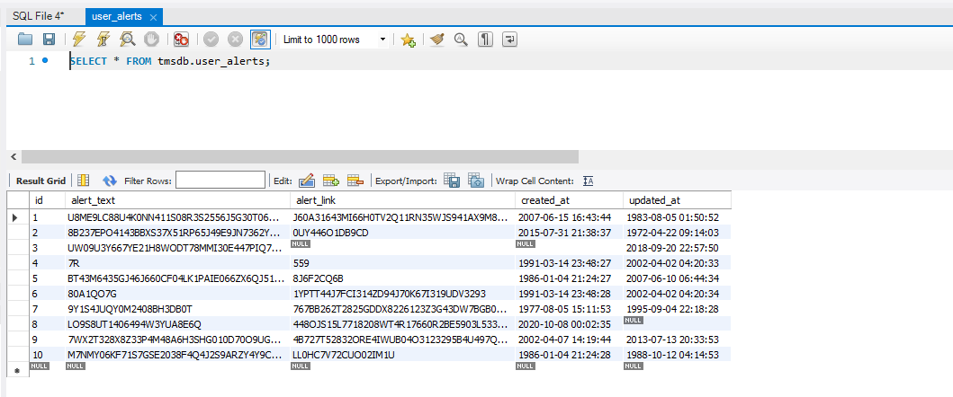

Figure User Alerts Table Inserted Data

**USER_USER_ALERTS TABLE**

INSERT INTO user_user_alert(user_alert_id, user_id, `read`) VALUES

(1, 1, 1),

(2, 2, 0);

**Inserted Data**

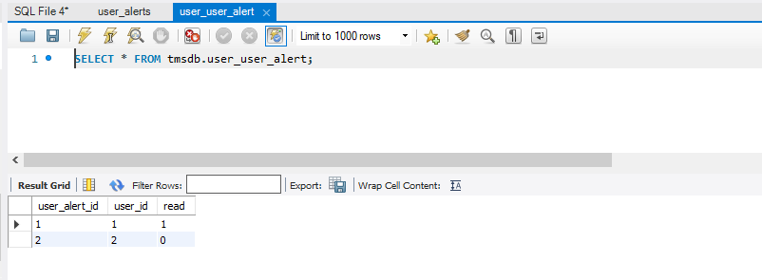

Figure user_user_alerts Table Inserted Data

**TASK_TASK_TAG TABLE**

INSERT INTO task_task_tag(task_id, task_tag_id) VALUES

(1, 1),(2, 2),(3, 3),(4, 4),(5, 5),(6, 6),(7, 7),(8, 8),(9, 9),(10, 10);

**Inserted Data**

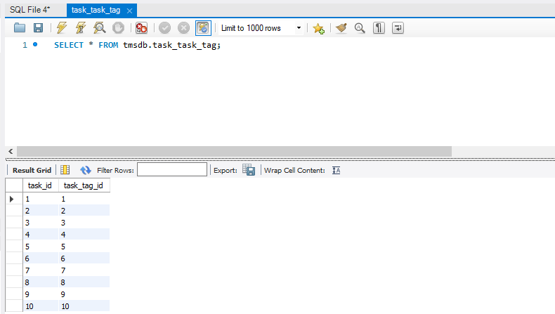

Figure task_task_tag Table Inserted Data

**TASK_TAGS TABLE**

INSERT INTO task_tags(id, name, created_at, updated_at, deleted_at) VALUES

(1, 'Summer1984', '2001-05-09 02:24:29', NULL, '1997-02-19 04:40:04'),

(2, 'Rigby751', '2019-06-15 16:34:46', '2003-03-25 03:18:37', '1982-04-25 05:53:44'),

(3, 'Brittny1989', '2007-08-17 02:31:13', '1971-10-07 21:42:25', '2012-01-18 11:42:56'),

(4, 'Noel2016', '2002-06-09 00:07:13', '1987-05-05 15:04:54', '1987-07-03 08:17:45'),

(5, NULL, '2007-08-17 02:31:14', '2008-06-01 05:42:38', '2006-11-10 09:18:56'),

(6, 'Carl1952', NULL, '1996-07-18 10:47:42', NULL),

(7, 'Weller1993', '2014-04-07 14:10:49', '1982-02-25 12:40:54', '2012-01-18 11:42:57'),

(8, 'Moe2003', '2002-06-09 00:07:14', '2003-03-25 03:18:38', '1991-12-13 02:16:04'),

(9, 'Tom2008', '1986-07-18 12:55:25', '1976-12-15 00:06:26', '2013-05-30 22:15:31'),

(10, 'Bernardo2022', '1996-03-01 00:00:29', '1987-05-05 15:04:55', '2006-11-10 09:18:57');

**Inserted Data**

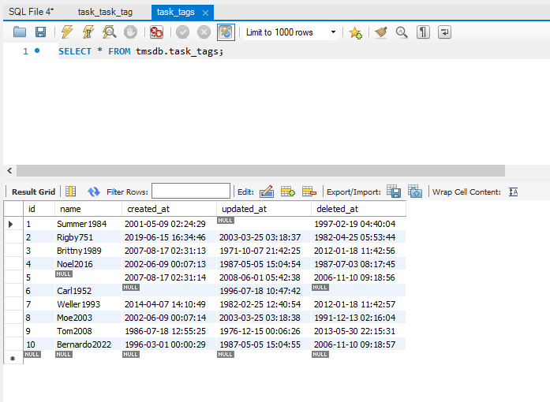

Figure task_tags Table Inserted Data

**TASK_STATUSES TABLE**

INSERT INTO task_statuses(id, name, created_at, updated_at, deleted_at) VALUES

(1, NULL, '1995-04-09 13:23:13', '1984-08-06 05:16:43', '2015-01-11 03:40:03'),

(2, 'Grayce2013', NULL, '1994-11-15 12:43:55', NULL),

(3, 'Durant791', '2008-12-19 14:08:54', '1989-10-14 07:40:44', '2002-06-09 16:54:25'),

(4, 'Lawrence747', '2003-10-12 11:44:54', '2000-01-23 15:07:56', '1971-01-01 00:00:05'),

(5, 'Newton6', '1987-06-06 11:50:00', '2015-09-29 14:55:56', '1998-06-01 10:47:35'),

(6, 'Twanda2006', '2017-09-21 14:49:00', '2020-12-06 17:19:54', '1986-05-08 02:28:48'),

(7, 'Granville1973', '2008-12-19 14:08:55', NULL, '2020-03-20 06:04:01'),

(8, 'Christena587', '1982-03-29 09:26:00', '1980-10-04 07:54:16', '2007-08-17 19:18:26'),

(9, 'Sunny2012', '2000-06-16 15:47:14', '1984-08-06 05:16:44', '1991-07-16 04:52:49'),

(10, 'Montanez857', '2003-10-12 11:44:55', '1994-11-15 12:43:56', '1976-03-10 02:24:06');

**Inserted Data**

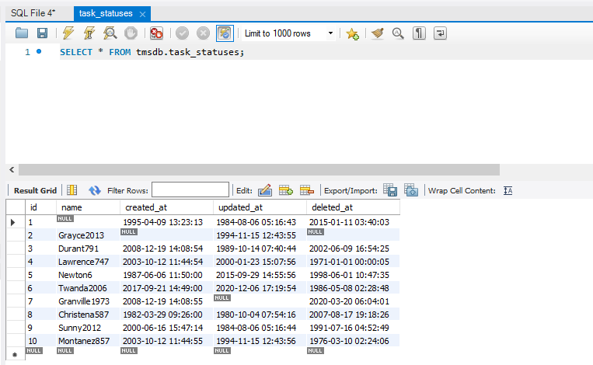

Figure task_statuses Table Inserted Data

**TASKS TABLE**

INSERT INTO `tasks` VALUES (1,'Define DB entities','Adipisci in totam qu','2022-11-25','2022-11-18 11:20:28','2022-11-18 11:20:28',NULL,1,2);

We reduced the insert query because it was too long. However, the table has all the data as shown in the screenshot of the inserted data.

**Inserted Data**

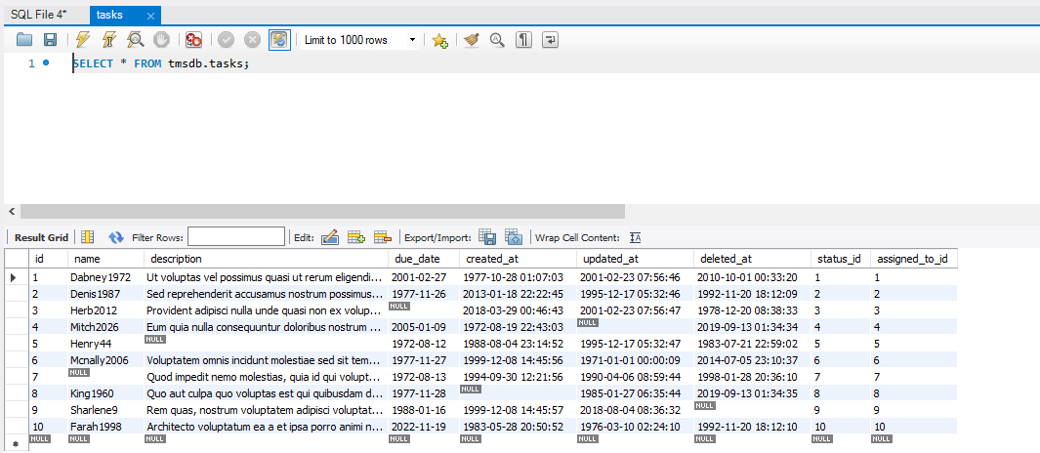

Figure tasks Table Inserted Data

**ROLE_USER TABLE**

INSERT INTO role_user(user_id, role_id) VALUES

(1, 1),

(2, 2),

(3, 3),

(4, 4),

(5, 5),

(6, 6),

(7, 7),

(8, 8),

(9, 9),

(10, 10);

**Inserted Data**

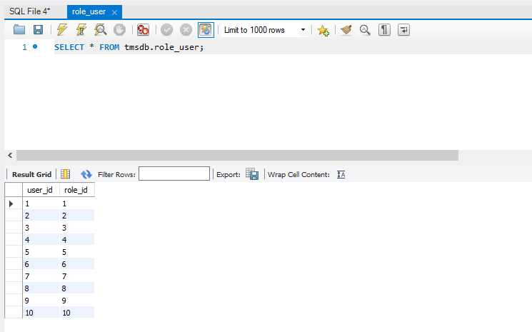

Figure role_user Table Inserted Data

**ROLES TABLE**

INSERT INTO roles(id, title, created_at, updated_at, deleted_at) VALUES

(1, 'Est dolorum quia unde.', '2006-11-14 00:19:16', '2002-11-25 22:24:14', '1983-04-30 17:16:21'),

(2, 'Veniam alias exercitationem id maxime.', '1995-10-23 19:41:15', '1995-10-08 23:33:01', '1993-02-25 11:34:16'),

(3, 'Omnis iste voluptatem sit veniam esse.', '2012-01-22 02:43:17', '1971-04-11 12:50:31', '1998-05-05 13:58:17'),

(4, NULL, '1981-09-25 23:37:21', NULL, '1993-02-25 11:34:17'),

(5, 'Nostrum eum id veritatis praesentium.', '2000-12-30 22:05:16', '1984-01-02 00:39:40', '1998-05-05 13:58:18'),

(6, 'Sequi unde id nostrum.', '1995-10-23 19:41:16', '2000-12-16 01:57:02', '1988-07-07 19:40:22'),

(7, 'Velit inventore nemo sint beatae quo.', '2000-12-30 22:05:17', '1989-03-11 03:03:41', '1971-10-22 07:18:35'),

(8, 'Et aut asperiores consequatur harum.', '2020-07-27 18:46:35', '2008-02-03 00:48:15', '1983-04-30 17:16:22'),

(9, 'Rerum culpa omnis eos molestiae.', NULL, '2020-07-10 13:00:01', '1988-07-07 19:40:23'),

(10, 'Dolorem sed ullam totam aut.', '1971-01-01 00:00:32', '2015-05-03 10:36:04', NULL);

**Inserted Data**

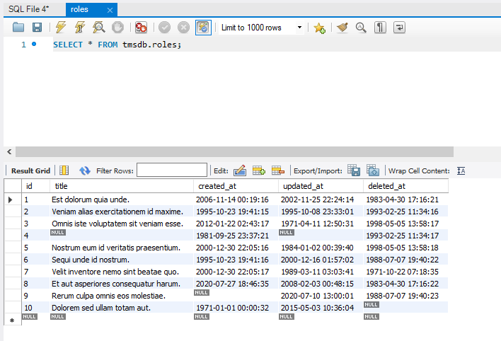

Figure roles Table Inserted Data

**PERSONAL_ACCESS_TOKENS TABLE**

INSERT INTO personal_access_tokens(id, tokenable_type, tokenable_id, name, token, abilities, last_used_at, created_at, updated_at) VALUES

(1,'70AMGS0ZHJ762KQ384988TSD3K7RN82X20SY09Q51T69186F6AH2K60C9FP42P6K63658URB6778S84S9BL8YAHJ4QK2US7988BHN92PN9D', 1, 'Anjanette589', '3Y53T4PQ80RWWE1Q55Y9278T7T6RB7EPB210BN13N1PHO5J2RH44V78', NULL, NULL, '1979-08-01 14:02:46', NULL),

(2, 'C046912CVR7P68AB734IT2Q9D76L1F5Q0PNY0R3481E13X971GZ', 2, 'Maria2023', '4N2FEA6A1K43HQIV1Q304H5JL2VW8TO', 'YVE121DHK7O1NX6ZF5X', '2016-03-09 03:28:31', '2005-03-30 07:48:27', '1981-01-29 18:55:17'),

(3, 'TBM1846K58UU427C61CJ1FY07Q951XS28LWS8C0596', 3, 'Mariel2013', 'VL9C7K434', '05793B', '2021-05-17 05:52:29', '1974-05-24 11:38:46', '2005-08-26 05:18:01'),

(4,'X9UC76A72LGDRS53RO0MI5K524K39F8Y70H5TL13AH56ALWG7VYJ6142KF4NS83LAW81573U6AF1H72319B0DS2V056F505T71KG5T2P1A2JX3T4EK936N19LHM644981FCMKY36A0V7E6ODCQ7RA6XDR0PQFPW', 4, 'Pemberton2024', 'IF03Z1U8C2QB034Q125MM2099H', '0L66SD28NP200Q18556Z20HQ5O6GXT80FWZ773WDP9AJXA268L18231N52U5035L5152BESN2R6854P0290O4P438WDV', '1971-01-01 00:00:04', '1979-08-01 14:02:47', '2022-03-25 09:10:53'),

(5, 'RY6HH5K2QG0I1QIC2GPT6QD3C42H7T5562P45G6W6MLI577B3R0Y0FLND4H2', 5, 'Orval2001', '0P', '3K3SBE130Q53KI6Z1', '1994-06-21 02:40:58', '2000-01-25 14:42:01', '2010-11-03 07:42:02'),

(6,'1N3H3U9MZ3XX88677WHRG75324B8I283D960MEXI3L65XCOD0501KO4QGG967KH6T015309LM0V236TY1N56V620T123X13YHFL', 6, 'Nunn17', 'M3TZR2AE3WX1', 'YJP54152H2V0I5Q14GWFW176', '1999-08-29 05:04:59', NULL, '1996-10-30 18:38:42'),

(7, 'U2K2WRY7QH235V1FK9A0M5E3S6', 7, 'Gidget585', 'UKON6O8D17G37K18I85VD0H', '17C589', '1983-10-07 04:50:39', '2022-08-13 07:21:15', '1981-06-07 05:52:35'),

(8, 'L4EBXJC7AZ73XOHI5PDB63H63BU4XD5K0AD2L16QLIWQN3T7R5V0HGH2JE0IEKY8AGI599', 8, 'Breana745', 'MKU8V7334PH16R20EXQI9', 'C34IT48C7BQ6FHUD0J4PZ07E56335TL18BTEEY0', '1994-06-21 02:40:59', '2010-06-07 10:12:28', '2017-01-15 06:46:56'),

(9, 'BO4EQKTYPU867QH5F1807V65GMU94', 9, 'Reed2001', '1NRD1MVL56Y1K17D1K2JL594SY0P6TB0', 'H1O14FS864S7146B9FB2T620M24Q', '1976-03-10 02:24:05', '1974-05-24 11:38:47', '2005-08-26 05:18:02'),

(10, '4X44O3375CKQ9NH05HQ878XR4C8IXM9L0Z8A152KOVA6190AY07LEP8', 10, 'Stiltner21', '80S125Q51U8H69JFL18TMJE21X36ATQIW6', '0922RBHG759B1', '1999-08-29 05:05:00', '1994-11-17 12:18:01', '1975-11-22 16:31:17');

**Inserted Data**

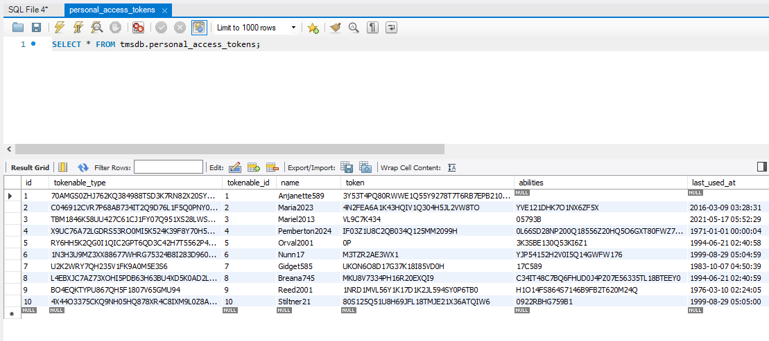

Figure personal_access_tokens Table Inserted Data

**PASSWORD_RESETS TABLE**

INSERT INTO password_resets(email, token, created_at) VALUES

('Scarbrough68@example.com','3002LLL4UL8TRV2J4H2HZ738ZYO6Y4ZM4E7A5BX6W0ZCBN34CG8AI29R524964214YEXE7557U37V06L7Y2TBXG71S50A7XFG398015JXWHCEZA46Q8GHR46I55492HW8KH3FT78CL699D7L5G1SHSCDHH46P4M1872', '2000-03-25 12:55:27'),

('Kidd@example.com','5LSV6Z8FE902CBQXB45U7HSI788Z2U7GIHAU53MC37F163U3M8ET47IU1W64Y3QA01084P5D5M5DZK3X2R595LA93MSI080560N1ED952OX49QLT25Y47A5R5Y6242G6BSQZ0IJ1F98K01W2W2DDOD041Z59ZJ1LBPG11HQA1DC29C52NPG7S16R3Z78BB5', '1995-01-16 10:31:27'),

('Lesley.Steinberg676@nowhere.com', '89226M0L9TI3Z0J8EW29Z9SU9S0', '2009-01-11 20:01:24'),

('VincentRoldan1@example.com', 'SJLBXYZ0Y699AHJVCD4MG34E385G9', '2000-03-25 12:55:28'),

('Bales@example.com','PRC8EFBKLFC4HQY85927ZZRFOW542801Q1V2L72R394345H47G0QKCW42JDKMU63SD6ZN8W34Z0EY4347FRS96J7MOE8C2STM72Y1F70JS', '1971-01-01 00:00:05'),

('rvhlsmqr_pkrvh@example.com','Q855PE1Y69P764N8AA1TC209V77Y2JPQSX7NTE4E50541CC9PA5O151YA0NDY12A9CHSZDB7KA105F2MPOT7D1VO77E058EA7ZD01X5J7WO6T33VSC17149Q4ZWT19BX9998UZL71P6F2B2A239JJ', '1995-01-16 10:31:28'),

('Debera_Lindquist@example.com', 'RU6228D5012IAGE', NULL),

('McdadeW37@example.com','12L58N813U2EJOX78247D9SOQG9863071S6E776ARH2698RK0F1UW5K54DU42Y9566HYHMGU5CO9O23', '2003-11-04 17:37:24'),

('TownsJ6@example.com', '8M5NJD968GBUG60P567C339143P0M9NB1', '2016-04-13 18:54:44'),

('Aubrey_Epps@example.com','X8B823ULOV95K4KB3C4Z6M5333NR030NJZTO6R3B483L68DJIZ7IA33P143Y8N24L6M8K7830ON4646ISRDK8CUI4W0CMK9F0HJYD1XM6CNAPFYR89RTMP1ZAX4R15QC7E3L1JZR4Q8G91CXII0198F4IJYHB6G1R2RZ25D9216W6UOF16640G98H479V9K', '2021-06-21 21:18:42');

**Inserted Data**

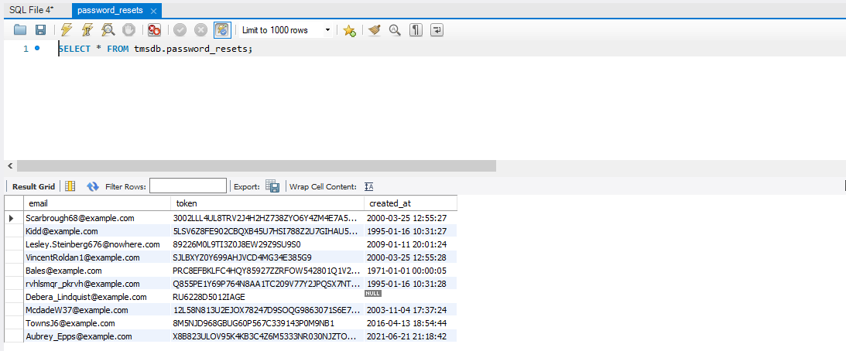

Figure password_resets Table Inserted Data

**PERMISSIONS TABLE**

INSERT INTO `permissions` VALUES (1,'user_management_access',NULL,NULL,NULL);

INSERT INTO `permissions` VALUES (2,'permission_create',NULL,NULL,NULL);

INSERT INTO `permissions` VALUES (3,'permission_edit',NULL,NULL,NULL);

INSERT INTO `permissions` VALUES (4,'permission_show',NULL,NULL,NULL);

INSERT INTO `permissions` VALUES (5,'permission_delete',NULL,NULL,NULL);

INSERT INTO `permissions` VALUES (6,'permission_access',NULL,NULL,NULL);

INSERT INTO `permissions` VALUES (7,'role_create',NULL,NULL,NULL);

INSERT INTO `permissions` VALUES (8,'role_edit',NULL,NULL,NULL);

INSERT INTO `permissions` VALUES (9,'role_show',NULL,NULL,NULL);

INSERT INTO `permissions` VALUES (10,'role_delete',NULL,NULL,NULL);

INSERT INTO `permissions` VALUES (11,'role_access',NULL,NULL,NULL);

INSERT INTO `permissions` VALUES (12,'user_create',NULL,NULL,NULL);

INSERT INTO `permissions` VALUES (13,'user_edit',NULL,NULL,NULL);

INSERT INTO `permissions` VALUES (14,'user_show',NULL,NULL,NULL);

INSERT INTO `permissions` VALUES (15,'user_delete',NULL,NULL,NULL);

INSERT INTO `permissions` VALUES (16,'user_access',NULL,NULL,NULL);

INSERT INTO `permissions` VALUES (17,'user_alert_create',NULL,NULL,NULL);

INSERT INTO `permissions` VALUES (18,'user_alert_show',NULL,NULL,NULL);

INSERT INTO `permissions` VALUES (19,'user_alert_delete',NULL,NULL,NULL);

INSERT INTO `permissions` VALUES (20,'user_alert_access',NULL,NULL,NULL);

INSERT INTO `permissions` VALUES (21,'task_management_access',NULL,NULL,NULL);

INSERT INTO `permissions` VALUES (22,'task_status_create',NULL,NULL,NULL);

INSERT INTO `permissions` VALUES (23,'task_status_edit',NULL,NULL,NULL);

INSERT INTO `permissions` VALUES (24,'task_status_show',NULL,NULL,NULL);

INSERT INTO `permissions` VALUES (25,'task_status_delete',NULL,NULL,NULL);

INSERT INTO `permissions` VALUES (26,'task_status_access',NULL,NULL,NULL);

INSERT INTO `permissions` VALUES (27,'task_tag_create',NULL,NULL,NULL);

INSERT INTO `permissions` VALUES (28,'task_tag_edit',NULL,NULL,NULL);

INSERT INTO `permissions` VALUES (29,'task_tag_show',NULL,NULL,NULL);

INSERT INTO `permissions` VALUES (30,'task_tag_delete',NULL,NULL,NULL);

INSERT INTO `permissions` VALUES (31,'task_tag_access',NULL,NULL,NULL);

INSERT INTO `permissions` VALUES (32,'task_create',NULL,NULL,NULL);

INSERT INTO `permissions` VALUES (33,'task_edit',NULL,NULL,NULL);

INSERT INTO `permissions` VALUES (34,'task_show',NULL,NULL,NULL);

INSERT INTO `permissions` VALUES (35,'task_delete',NULL,NULL,NULL);

INSERT INTO `permissions` VALUES (36,'task_access',NULL,NULL,NULL);

INSERT INTO `permissions` VALUES (37,'tasks_calendar_access',NULL,NULL,NULL);

INSERT INTO `permissions` VALUES (38,'profile_password_edit',NULL,NULL,NULL);

**Inserted Data**

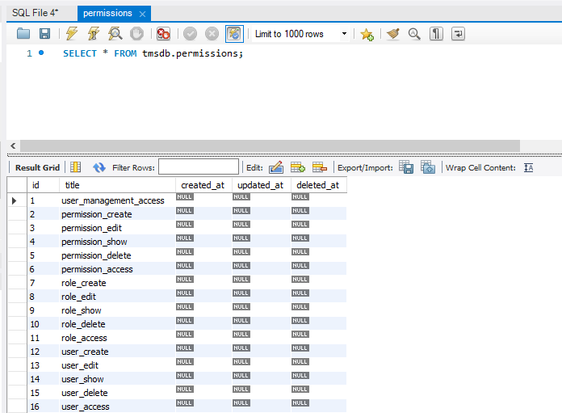

Figure permissions Table Inserted Data

**MIGRATIONS TABLE**

INSERT INTO `migrations` VALUES (1,'2014_10_12_100000_create_password_resets_table',1);

INSERT INTO `migrations` VALUES (2,'2019_12_14_000001_create_personal_access_tokens_table',1);

INSERT INTO `migrations` VALUES (3,'2022_11_18_000001_create_media_table',1);

INSERT INTO `migrations` VALUES (4,'2022_11_18_000002_create_permissions_table',1);

INSERT INTO `migrations` VALUES (5,'2022_11_18_000003_create_roles_table',1);

INSERT INTO `migrations` VALUES (6,'2022_11_18_000004_create_users_table',1);

INSERT INTO `migrations` VALUES (7,'2022_11_18_000005_create_user_alerts_table',1);

INSERT INTO `migrations` VALUES (8,'2022_11_18_000006_create_task_statuses_table',1);

INSERT INTO `migrations` VALUES (9,'2022_11_18_000007_create_task_tags_table',1);

INSERT INTO `migrations` VALUES (10,'2022_11_18_000008_create_tasks_table',1);

INSERT INTO `migrations` VALUES (11,'2022_11_18_000009_create_permission_role_pivot_table',1);

INSERT INTO `migrations` VALUES (12,'2022_11_18_000010_create_role_user_pivot_table',1);

INSERT INTO `migrations` VALUES (13,'2022_11_18_000011_create_user_user_alert_pivot_table',1);

INSERT INTO `migrations` VALUES (14,'2022_11_18_000012_create_task_task_tag_pivot_table',1);

INSERT INTO `migrations` VALUES (15,'2022_11_18_000013_add_relationship_fields_to_tasks_table',1);

**Inserted Data**

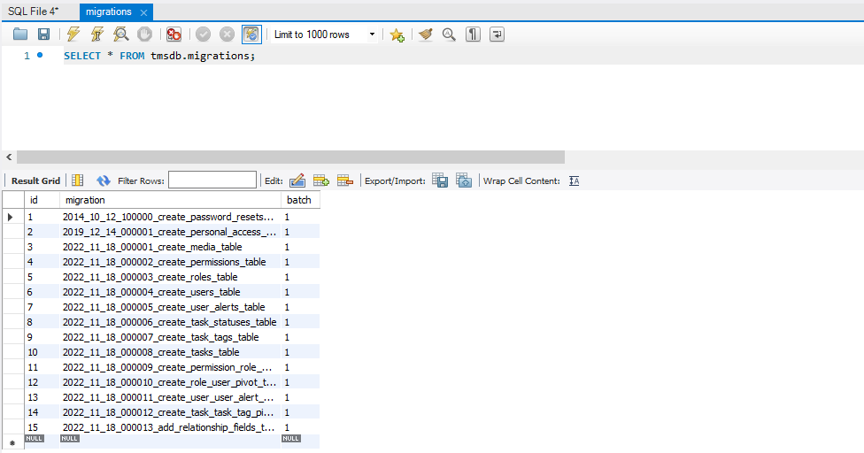

Figure migrations Table Inserted Data

**PERMISSION_ROLE TABLE**

INSERT INTO `permission_role` VALUES (1,1);

INSERT INTO `permission_role` VALUES (1,2);

INSERT INTO `permission_role` VALUES (1,3);

INSERT INTO `permission_role` VALUES (1,4);

INSERT INTO `permission_role` VALUES (1,5);

INSERT INTO `permission_role` VALUES (1,6);

INSERT INTO `permission_role` VALUES (1,7);

INSERT INTO `permission_role` VALUES (1,8);

INSERT INTO `permission_role` VALUES (1,9);

INSERT INTO `permission_role` VALUES (1,10);

INSERT INTO `permission_role` VALUES (1,11);

**Inserted Data**

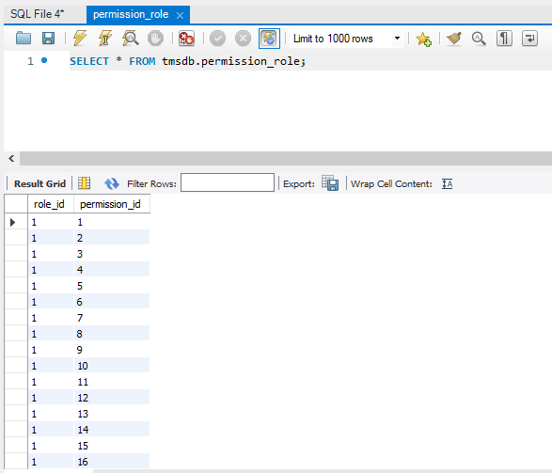

Figure permission_role Table Inserted Data

## Manipulating Data

## ALTER DATA

We use ALTER command which comes under Data Definition Language to add alert_type to the user_alerts table.

**ALTER USER ALERTS**

ALTER TABLE user_alerts

ADD alert_type varchar(15);

Now we see that the alert_type has been added to the table.

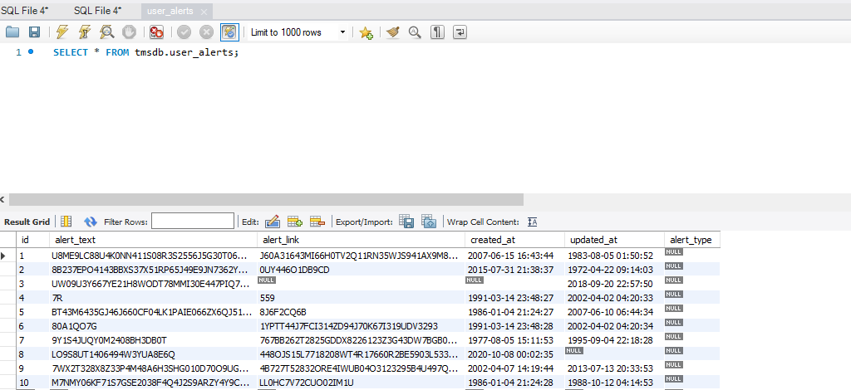

Figure Alter Table Task

**DROP CONSTRAINT IN MEDIA TABLE**

**ALTER TABLE Media**

DROP COLUMN collection_name;

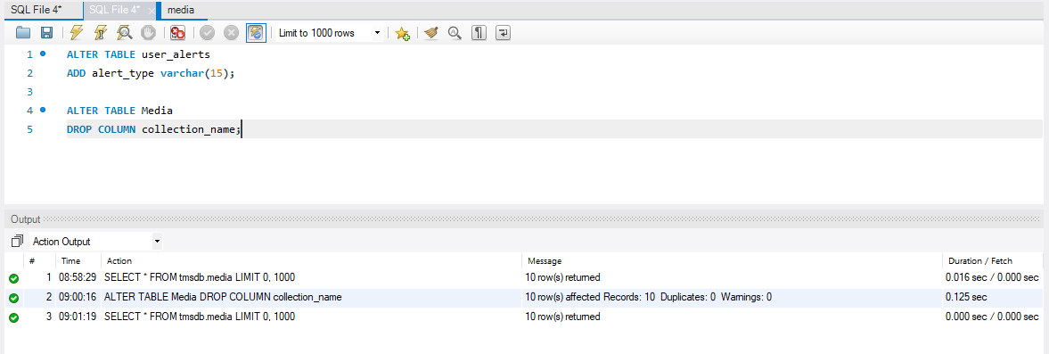

Figure Drop Column

**ALTER MEDIA TABLE**

ALTER TABLE Media

MODIFY COLUMN id bigint(10);

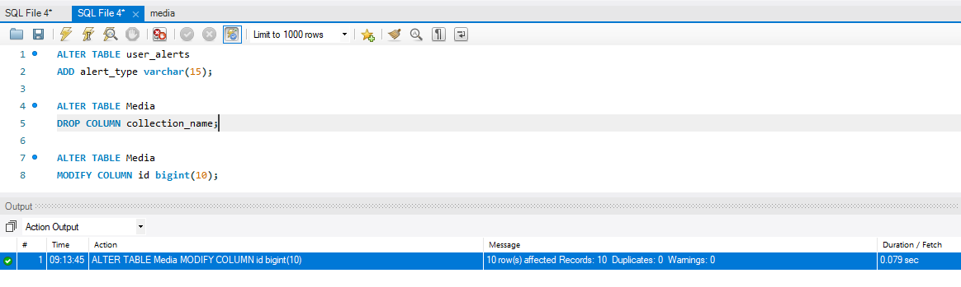

Figure Alter Media Table

**SELECT QUERY**

Selecting all from permissions table

SELECT * FROM tmsdb.permissions;

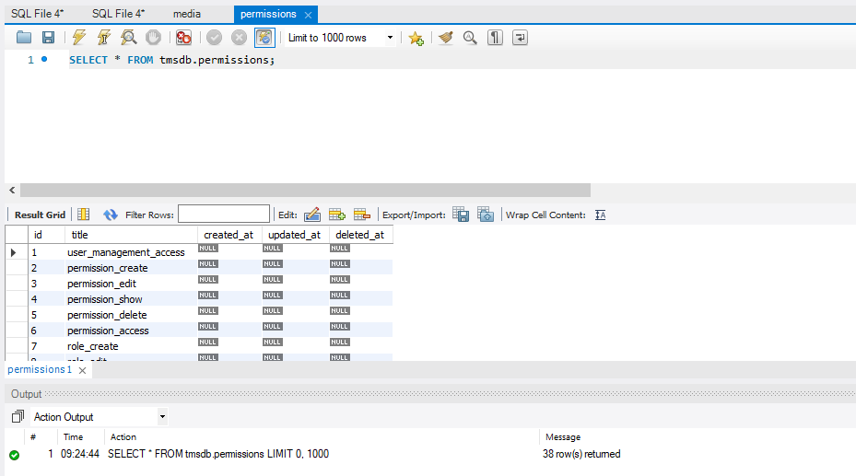

Figure Select All Query

**UPDATE DATA:**

We use UPDATE command which comes under Data Manipulation Language to update the values in the database table.

update task

**UPDATE USERS TABLE**

UPDATE users

SET name = 'Ben White', email = 'benwhite233@gmail.com'

WHERE id = 3;

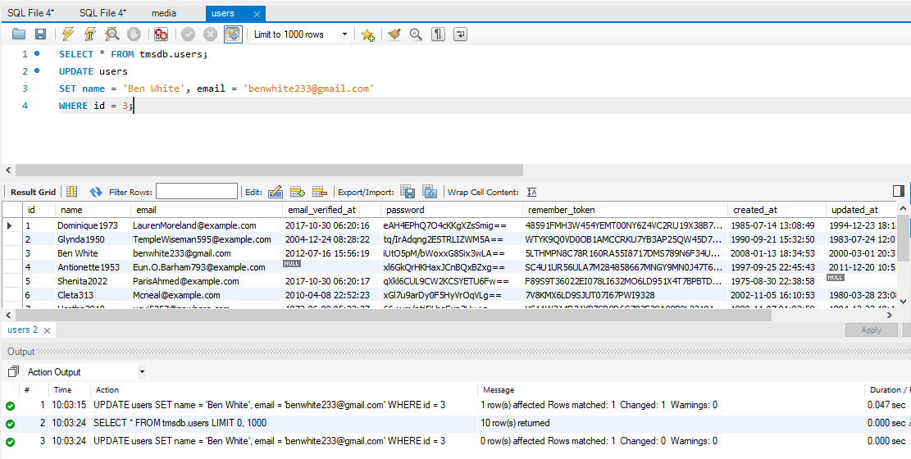

Figure Update Query

# OPTIMIZING DATABASE

Optimizing queries may be a component of database performance tuning since inefficient queries are frequently the cause of performance issues. Indexes are another crucial component of a database, along with queries. Your data will remain structured thanks to indexing, which also makes it simpler to find.

One of the best strategies that can use to improve database speed is to defragment the information.

The database will unavoidably get splintered as a result of the frequent writing and deleting of data, which might make it more difficult or slower to retrieve data or execute a query plan.

We need to find out the performance of our database. So By doing, we will be able to identify any performance issues in the database. In this case, we make use of the SQL **EXPLAIN** Statement.

The Explain Statement provides information about the query plan chosen.

**Permissions Select Query 1**

To start with, we will query data from our permissions table and see how long the query takes to return data.

Below is the output.

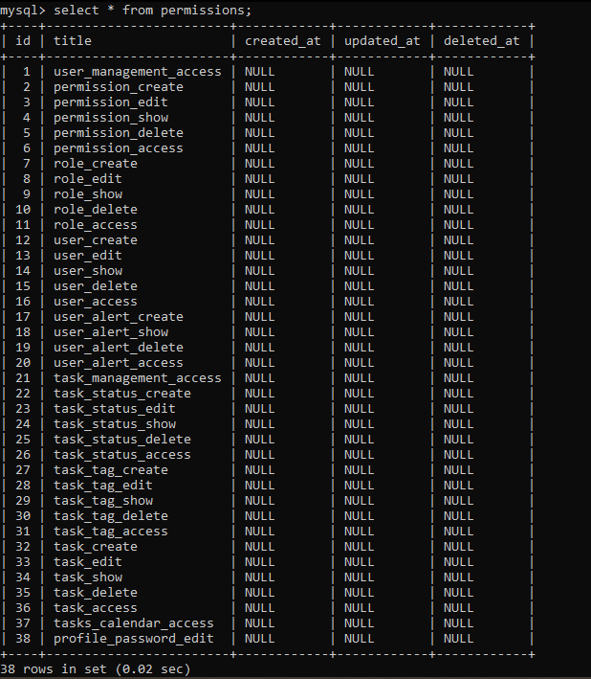

From the image above we see that is took 0.02 seconds.

We use explain to see the list of expected output from our query. The output is as shown below.

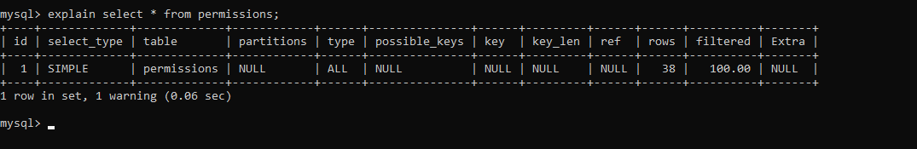

Execution plan is as follows

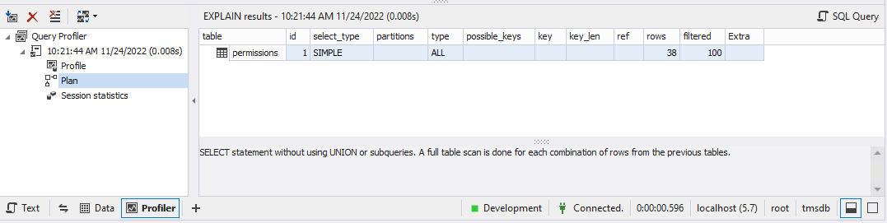

**Users Select Query 2**

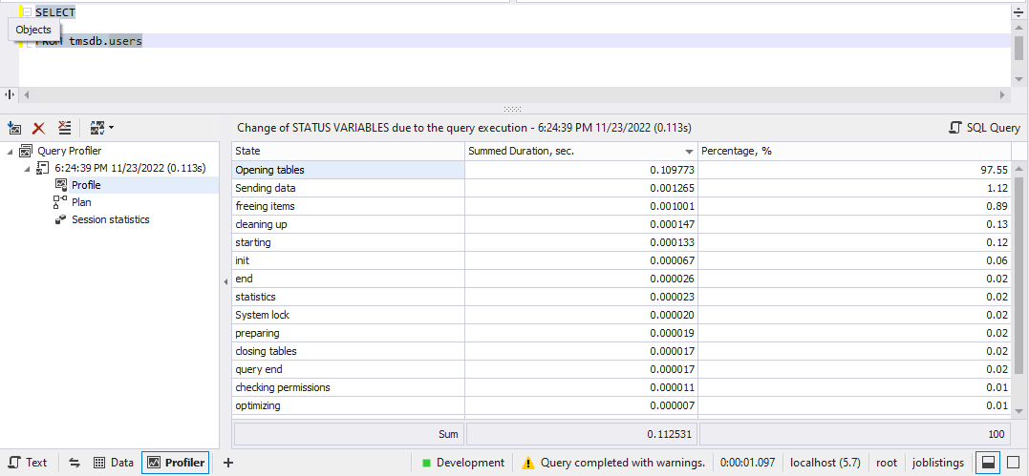

Running the select all from the users table took 0.11 seconds to execute.

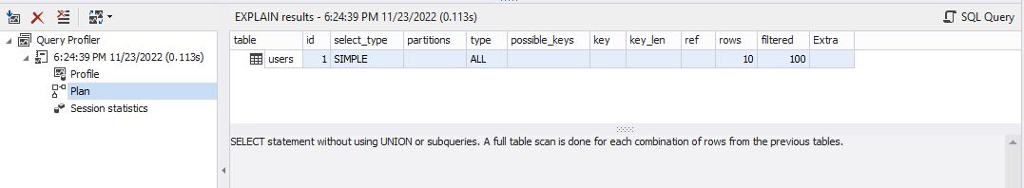

The EXPLAIN Statement shows that a total of 10 rows were returned as shown in the execution plan.

**Users select query 3**

The following select query selects tasks whose id is equal to 1. Below is the performance indication of the query which was executed in 0.0024 seconds.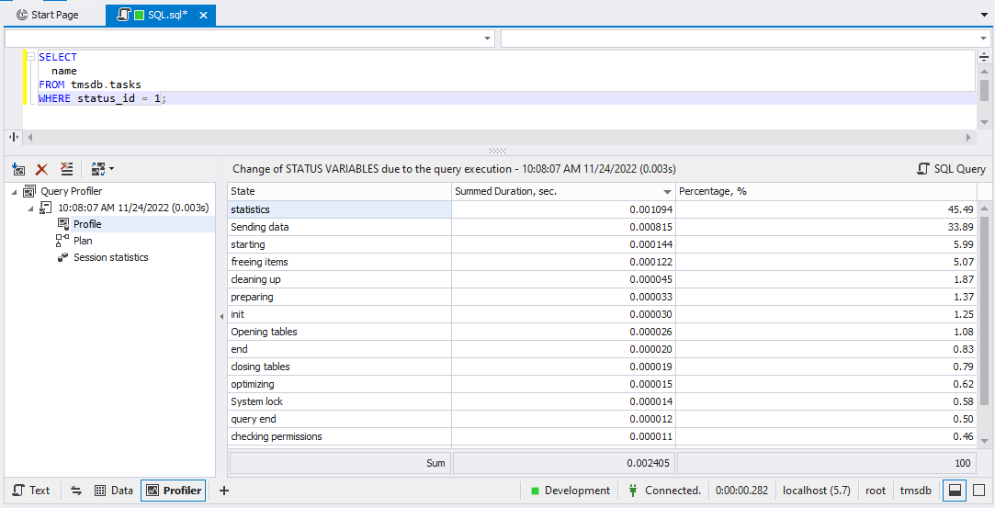

Below EXPLAIN query shows that a simple query was ran. Also, a foreign key was used and one row was returned.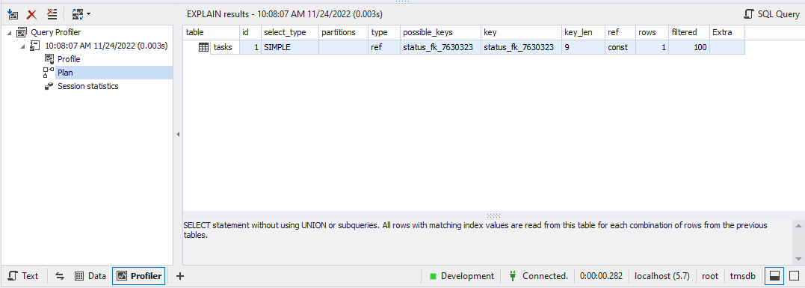

The following are the session statistics.

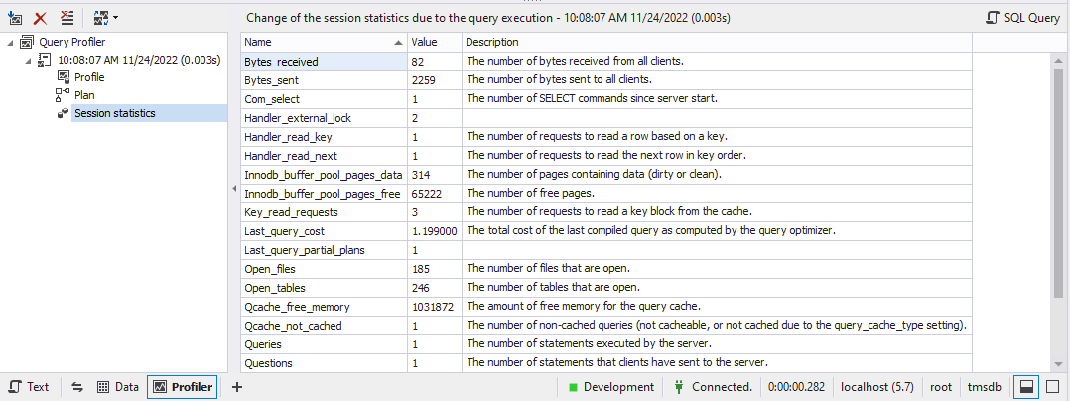

**Join query 1**

The join query joins the tasks table with task_statuses. Below are the query results which ran in 0.009651 seconds.

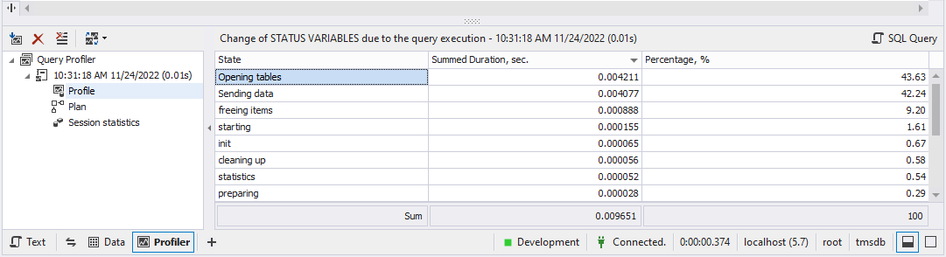

Execution plan with EXPLAIN Statement. Two tables were involving and 10 rows were returned.

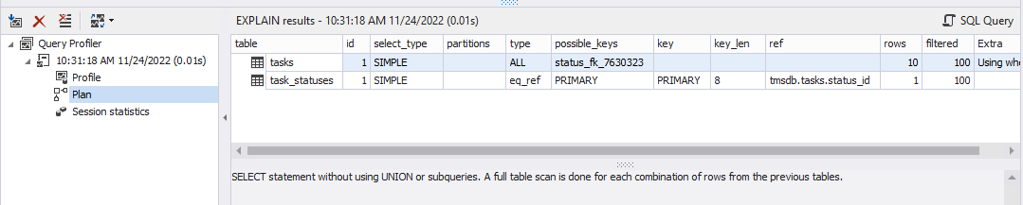

Session statistics

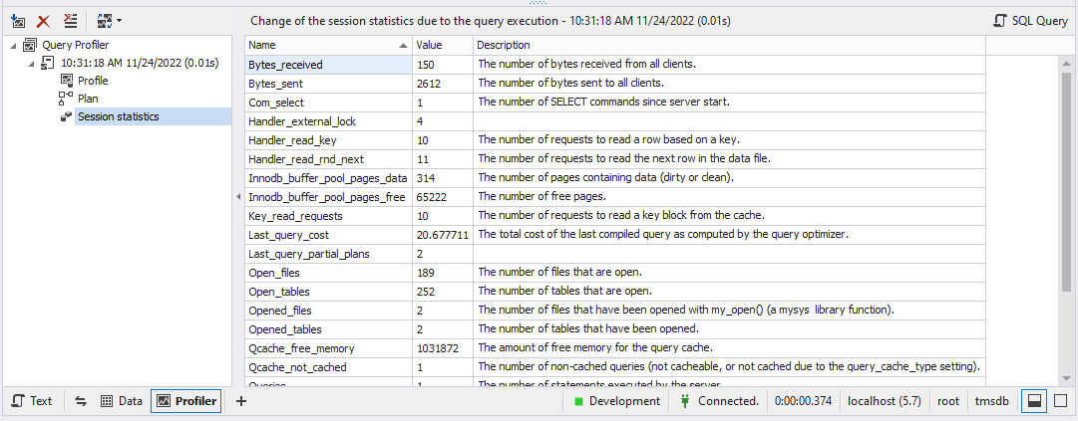

**Join Query 2**

The below query inner joins the users and role_users tables

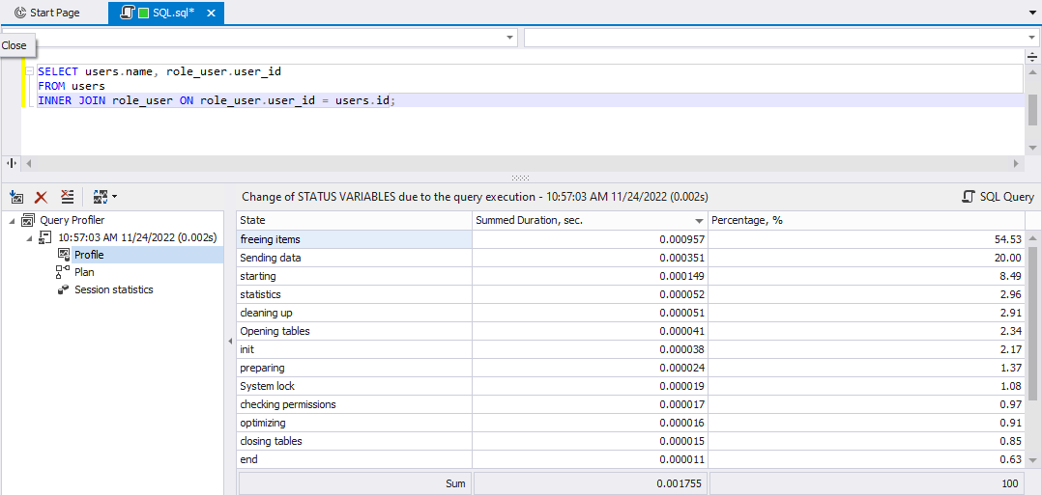

The query runs in 0.001755.

Execution plan

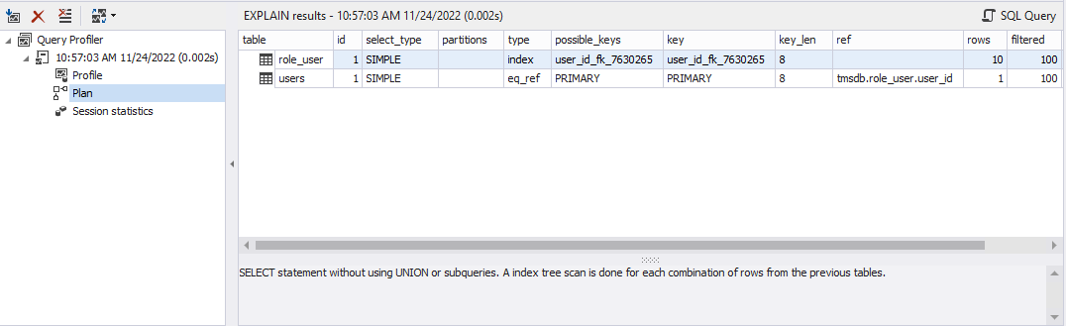

Session statistics

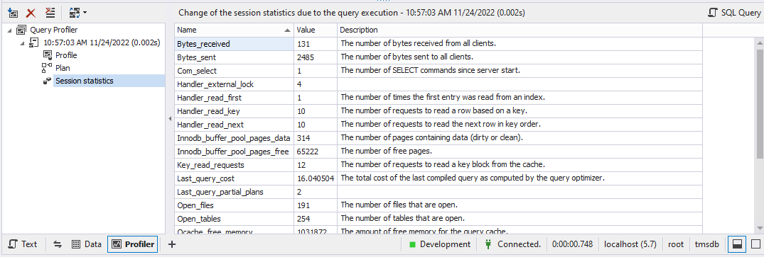

**Join Query 3**

Permissions and permissions_role inner join. Query executed in 0.008717 seconds.

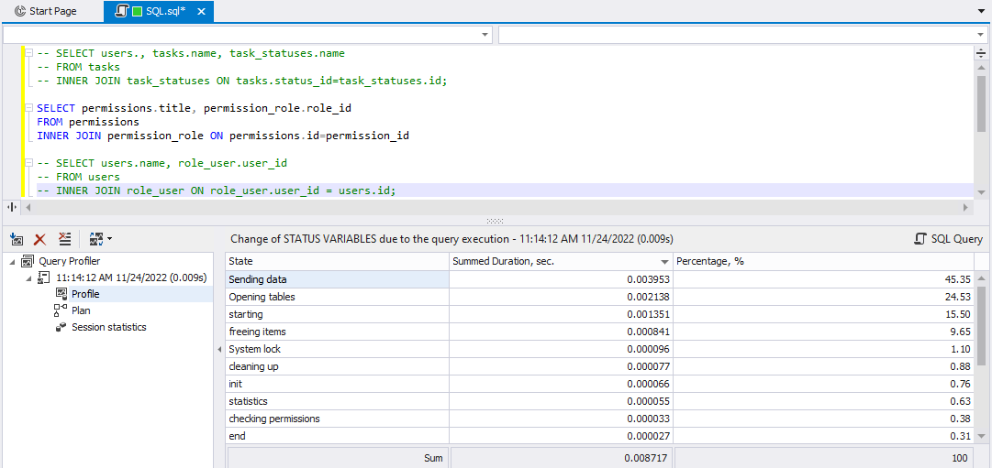

Explain results.

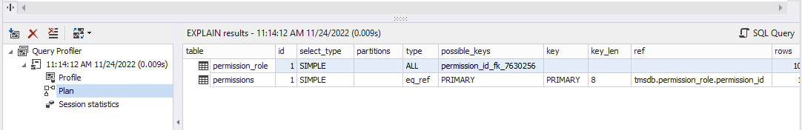

Session statistics

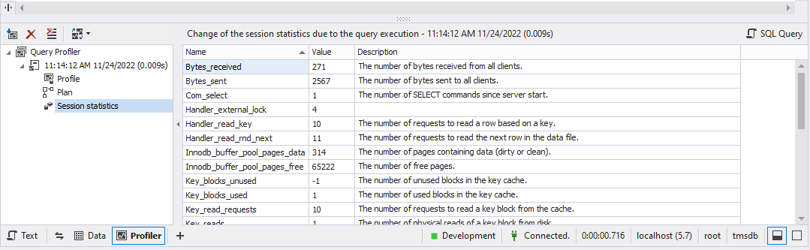

Triggers

create trigger task_triggers

after INSERT

on

task

for each row

UPDATE task set task.status = task.tid || ' complete' || task.aid;

SHOW TRIGGERS

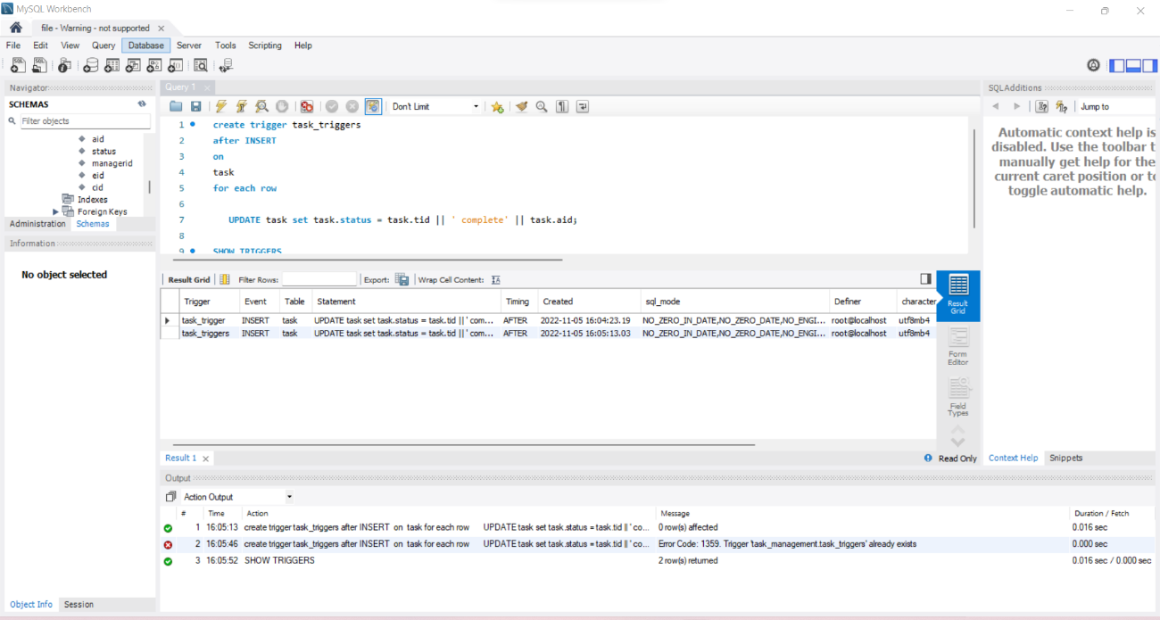

## Graphical user interface design

This GUI has login option, there the user has to enter their username and password. If the user is a new user, then he has to register first before being allowed to log in to the system. For connection, we used the Laravel auth system with jQuery and Bootstrap. We used Visual Studio Code as our IDE. To connect the database to the app, we entered the name of the database in the environments file (.env) and created the database with the same exact name in the PHPMyAdmin database server. We then ran the command, ‘php artisan migrate’ on the terminal. This command creates all the tables in the migrations of our app. Now, we need to run the app using the ‘php artisan serve’ command on the terminal. The app will run on the development server with the address 127.0.0.1 and on port 8000 by default. We copied the address which looked like this 127.0.0.1:8000 in the address bar of our browser. Now the user can view the homepage. After login to the system, he can see action items, there he can update his name, password etc. This is the flow chart of the process.

Figure 22 GUI Flow chart using EDI tool

## Connection in App Environment

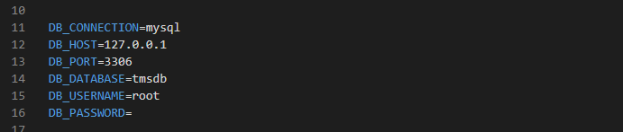

## Home Page Source Code

This page should get the username and password values from the end user and check with the database. If the user was a legitimate one, the program should allow the user to proceed with the other pages. Otherwise, it should show a warning of incorrect username or password.

* The main menu provides the list of all available options to the end user. These options include insertion, deletion, modification, searching, and printing all the available items in the database. If the user has the role of admin, he/she should also have access to user administration as well.
* The user administration page should provide the capability of adding, removing, and updating users’ information: username, password, role/privilege.
* The regular users should only be allowed to change their passwords.

<!DOCTYPE html>

<html lang="en">

<head>

    <meta charset="UTF-8">

    <meta name="viewport" content="width=device-width, initial-scale=1.0">

    <meta http-equiv="X-UA-Compatible" content="ie=edge">

    <title>TMS</title>

    <link rel="canonical" href="https://getbootstrap.com/docs/5.2/examples/heroes/">

    {{-- <link href="{{ asset('css/bootstrap.min.css')}}" rel="stylesheet" integrity="sha384-Zenh87qX5JnK2Jl0vWa8Ck2rdkQ2Bzep5IDxbcnCeuOxjzrPF/et3URy9Bv1WTRi" crossorigin="anonymous"> --}}

        <!-- Favicons -->

    <link rel="apple-touch-icon" href="/docs/5.2/assets/img/favicons/apple-touch-icon.png" sizes="180x180">

    <link rel="icon" href="/docs/5.2/assets/img/favicons/favicon-32x32.png" sizes="32x32" type="image/png">

    <link rel="icon" href="/docs/5.2/assets/img/favicons/favicon-16x16.png" sizes="16x16" type="image/png">

    <link rel="manifest" href="/docs/5.2/assets/img/favicons/manifest.json">

    <link rel="mask-icon" href="/docs/5.2/assets/img/favicons/safari-pinned-tab.svg" color="#712cf9">

    <link rel="icon" href="/docs/5.2/assets/img/favicons/favicon.ico">

    <meta name="theme-color" content="#712cf9">

    <link rel="https://cdn.jsdelivr.net/npm/bootstrap@5.2.2/dist/css/bootstrap.min.css" href="style.css">

    <link href="{{ asset('css/heroes.css') }}" rel="stylesheet">

    <link href="{{ asset('css/bootstrap.min.css') }}" rel="stylesheet">

    <link href="{{ asset('css/custom.css') }}" rel="stylesheet" />

    @yield('styles')

</head>

<body>

    <main>

        <div id="id">

            @include('partials.navbar')

        <h1 class="visually-hidden">TMS</h1>

        <div class="px-4 py-5 my-5 text-center">

            <img class="d-block mx-auto mb-4" src="{{ asset('img/icons8-stream-logo.svg') }}" alt="" width="72" height="57">

            <h1 class="display-5 fw-bold">Task Management System</h1>

            <div class="col-lg-6 mx-auto">

            <p class="lead mb-4">Welcome to the Task Management System. Get Control of your tasks </p>

            <div class="d-grid gap-2 d-sm-flex justify-content-sm-center">

                <a href="{{ route('login') }}"><button type="button" class="btn btn-primary btn-lg px-4 gap-3">Login</button></a>

                <a href="{{ route('register') }}"><button type="button" class="btn btn-outline-secondary btn-lg px-4">Register</button></a>

            </div>

            </div>

        </div>

        </div>

    </main>

</body>

    <script src="https://cdn.jsdelivr.net/npm/bootstrap@5.2.2/dist/js/bootstrap.bundle.min.js"></script>

    <script src="https://cdnjs.cloudflare.com/ajax/libs/jquery/3.3.1/jquery.min.js"></script>

    <script src="https://stackpath.bootstrapcdn.com/bootstrap/4.1.1/js/bootstrap.min.js"></script>

    <script src="https://cdnjs.cloudflare.com/ajax/libs/popper.js/1.14.3/umd/popper.min.js"></script>

    <script src="https://cdnjs.cloudflare.com/ajax/libs/jquery.perfect-scrollbar/1.5.0/perfect-scrollbar.min.js"></script>

    <script src="//cdn.datatables.net/1.10.19/js/jquery.dataTables.min.js"></script>

    <script src="https://cdn.datatables.net/1.10.19/js/dataTables.bootstrap4.min.js"></script>

    <script src="//cdn.datatables.net/buttons/1.2.4/js/dataTables.buttons.min.js"></script>

    <script src="//cdn.datatables.net/buttons/1.2.4/js/buttons.flash.min.js"></script>

    <script src="https://cdn.datatables.net/buttons/1.2.4/js/buttons.html5.min.js"></script>

    <script src="https://cdn.datatables.net/buttons/1.2.4/js/buttons.print.min.js"></script>

    <script src="https://cdn.datatables.net/buttons/1.2.4/js/buttons.colVis.min.js"></script>

    <script src="https://cdn.rawgit.com/bpampuch/pdfmake/0.1.18/build/pdfmake.min.js"></script>

    <script src="https://cdn.rawgit.com/bpampuch/pdfmake/0.1.18/build/vfs_fonts.js"></script>

    <script src="//cdnjs.cloudflare.com/ajax/libs/jszip/2.5.0/jszip.min.js"></script>

    <script src="https://cdn.datatables.net/select/1.3.0/js/dataTables.select.min.js"></script>

    <script src="https://cdn.ckeditor.com/ckeditor5/16.0.0/classic/ckeditor.js"></script>

    <script src="https://cdnjs.cloudflare.com/ajax/libs/moment.js/2.22.2/moment.min.js"></script>

    <script src="https://cdnjs.cloudflare.com/ajax/libs/bootstrap-datetimepicker/4.17.47/js/bootstrap-datetimepicker.min.js"></script>

    <script src="https://cdnjs.cloudflare.com/ajax/libs/select2/4.0.5/js/select2.full.min.js"></script>

    <script src="https://cdnjs.cloudflare.com/ajax/libs/dropzone/5.5.1/min/dropzone.min.js"></script>

    <script src="{{ asset('js/main.js') }}"></script>

    @yield('scripts')

</html>

## Screenshots:

Homepage

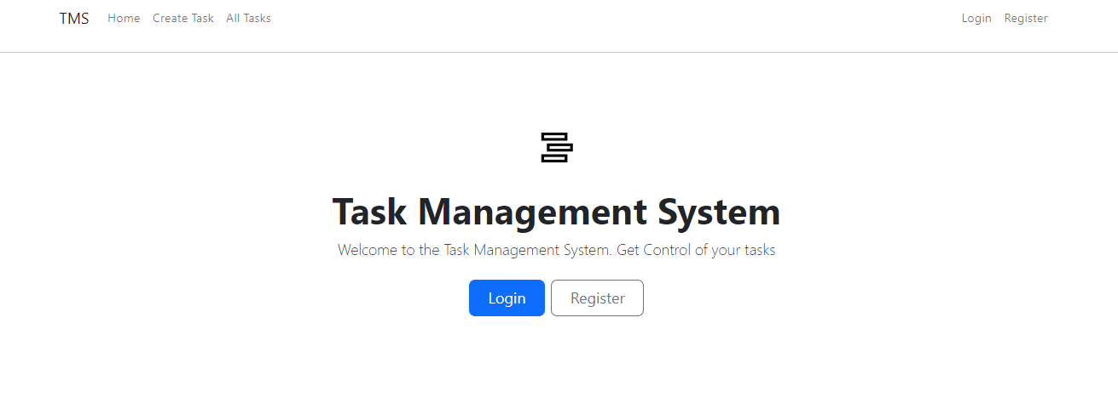

Login page

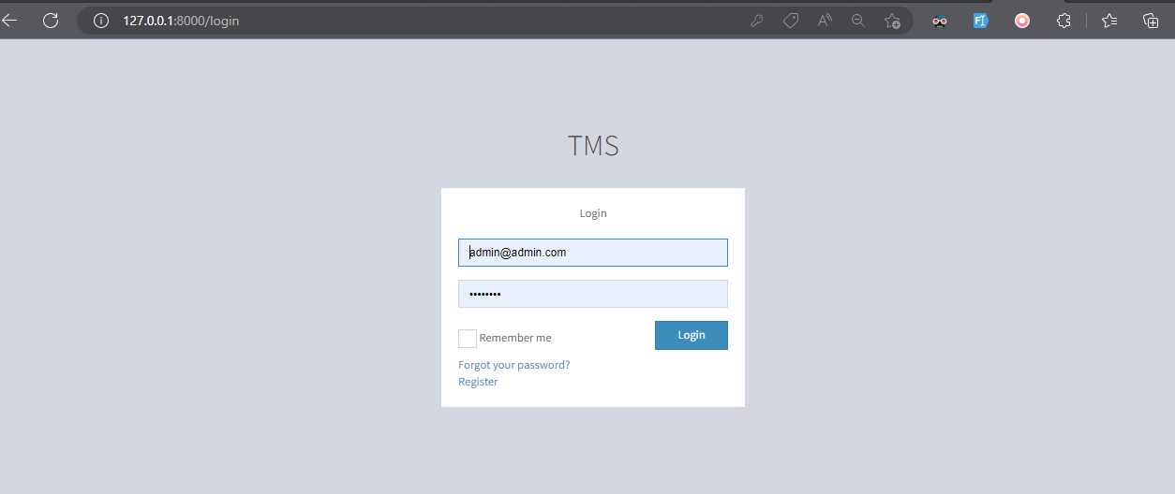

Registration page

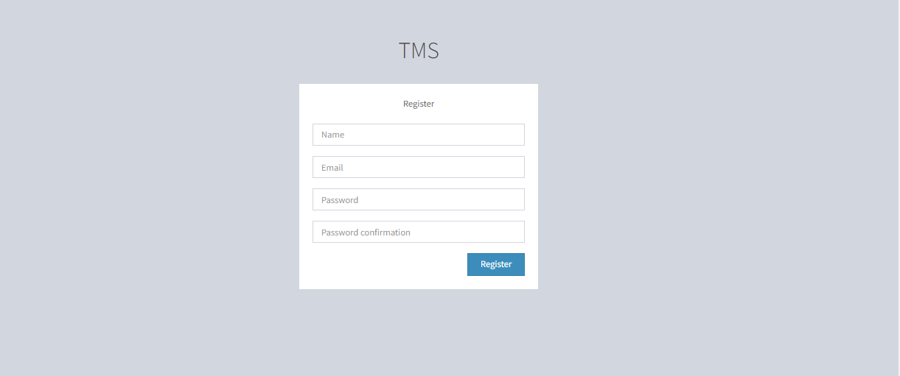

# Conclusion

This project has been incredibly helpful in honing our development abilities. All the steps a professional would take to manage a project have been thoroughly covered. Despite some difficulties along the way, everyone in the group agreed that the project was a true test and had given them many new skills. Unified diagram modelling, MySQL database management, and backend and frontend web development are some of these skills. We are all sincerely appreciative of our instructor's project execution selection. The knowledge we have gained will be extremely useful in our future careers.

# Future Works

This project has a lot of practical and logical features. However, it still leaves so much room for improvement. For instance, it would be good to collaborate on tasks. Multiple people can work on rather handful tasks to complete the tasks in time. Additionally, the system can have reminders have tasks that are new or overdue. This will encourage the completion of more tasks by individuals. It would also be ideal for the system to check for individuals assigned a lot of tasks and allocate new tasks to individuals with the least number of tasks. This will prevent some people from being overwhelmed.

**References:**

* [1] Cheng, D. R., & South, M. (2020). Electronic task management system: a pediatric institution's experience. *Applied Clinical Informatics*, *11*(05), 839- 845.
* Mikelsone, E., Spilbergs, A., Segers, J. P., Volkova, T., & Liela, E. (2022). Better Ideation Task Results in Web-Based Idea Management Systems. *Businesses*, *2*(2), 129-140.
* [2] <https://www.consumervoice.org/wrike-review>
* [3] https://project-management.com/calendar-software/